**Work Instructions for Routing Request (MS ACCESS)**

**Request Form**

1. Click New Request in Main Menu

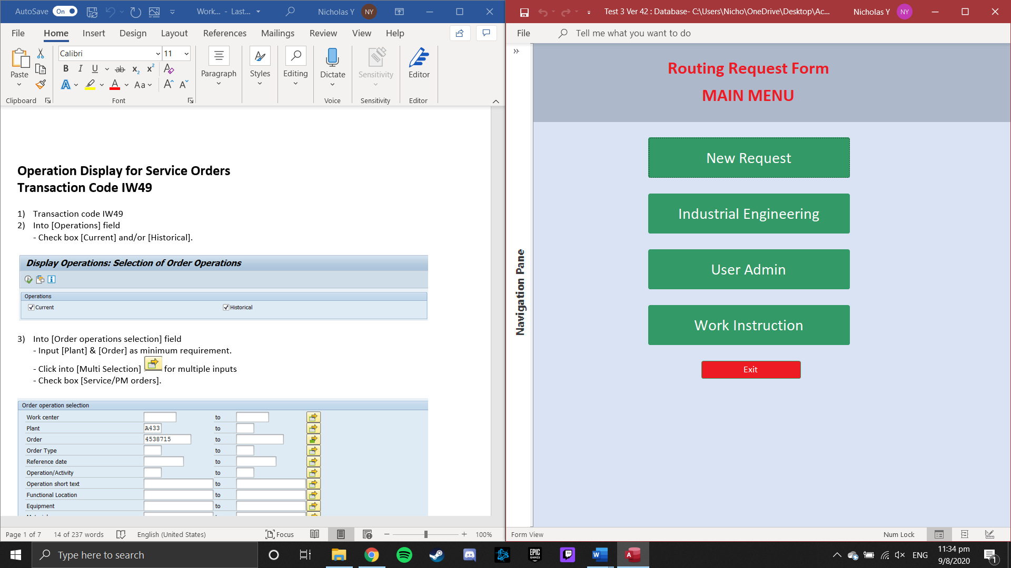

1. 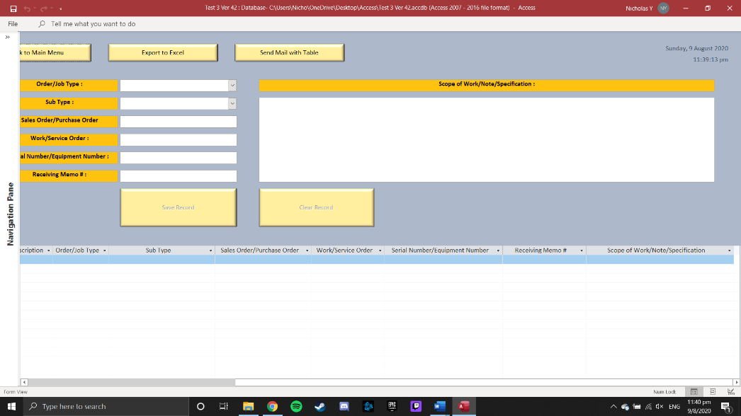Key in required fields

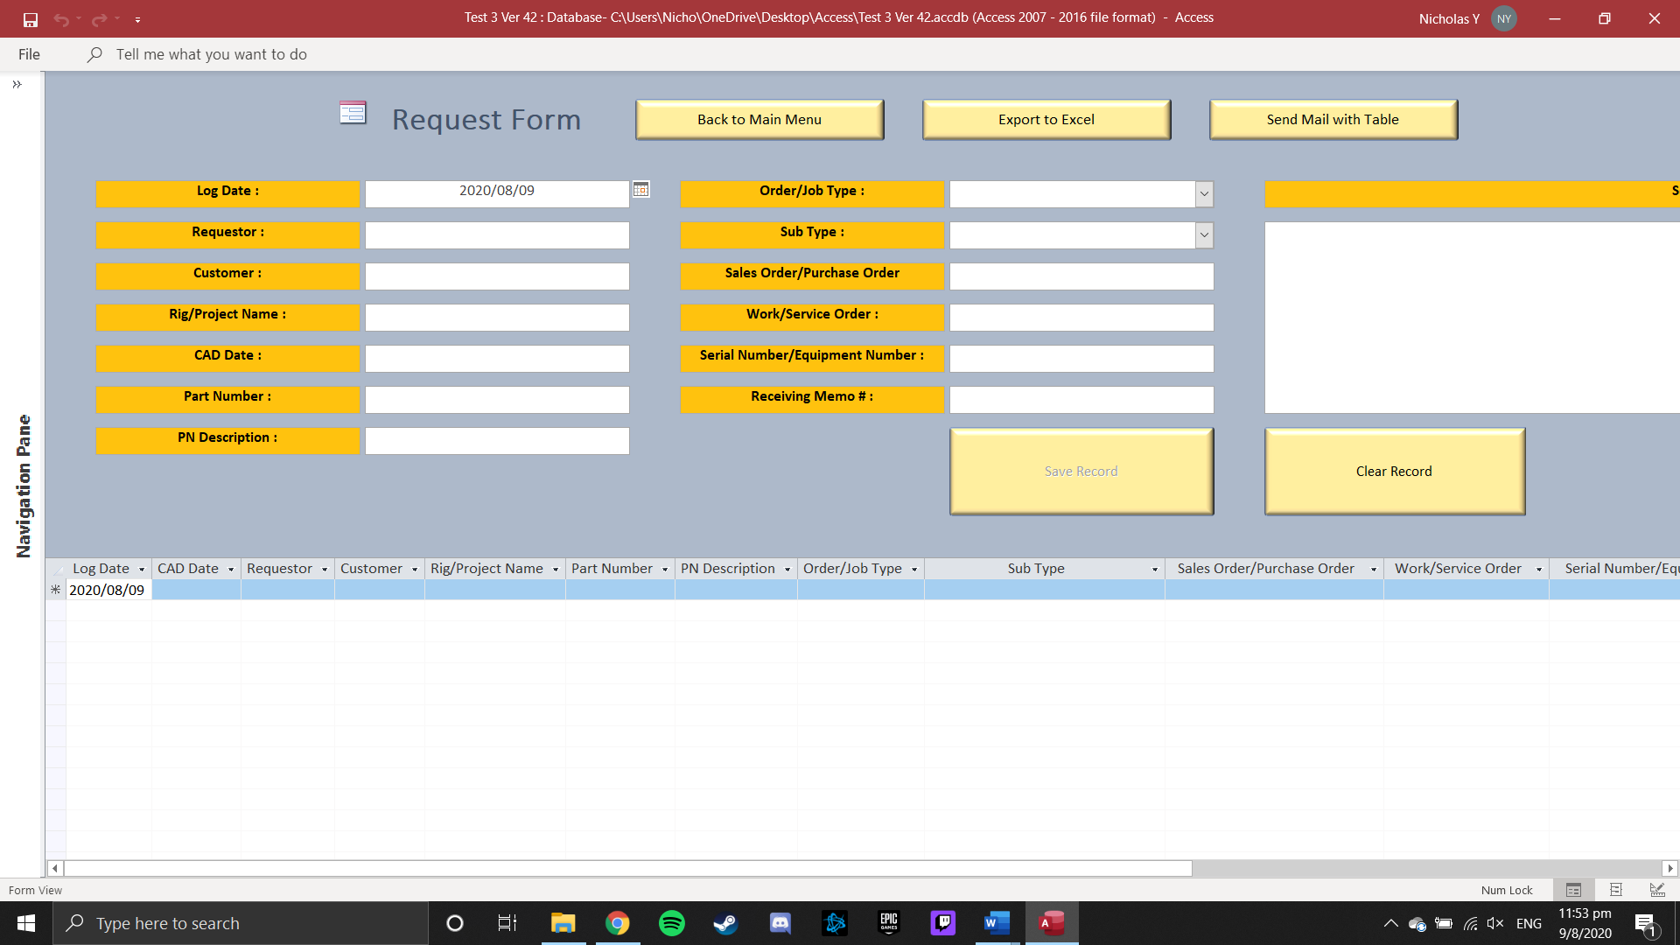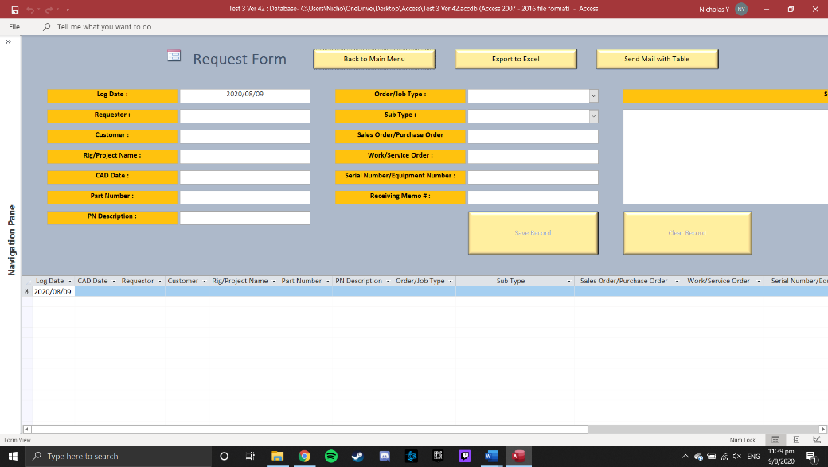

1. Click on beside [Log Date] and [CAD Date] to select date using Date Picker

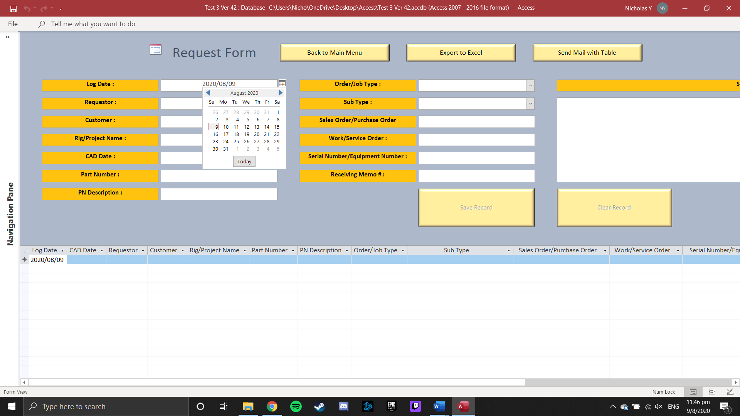

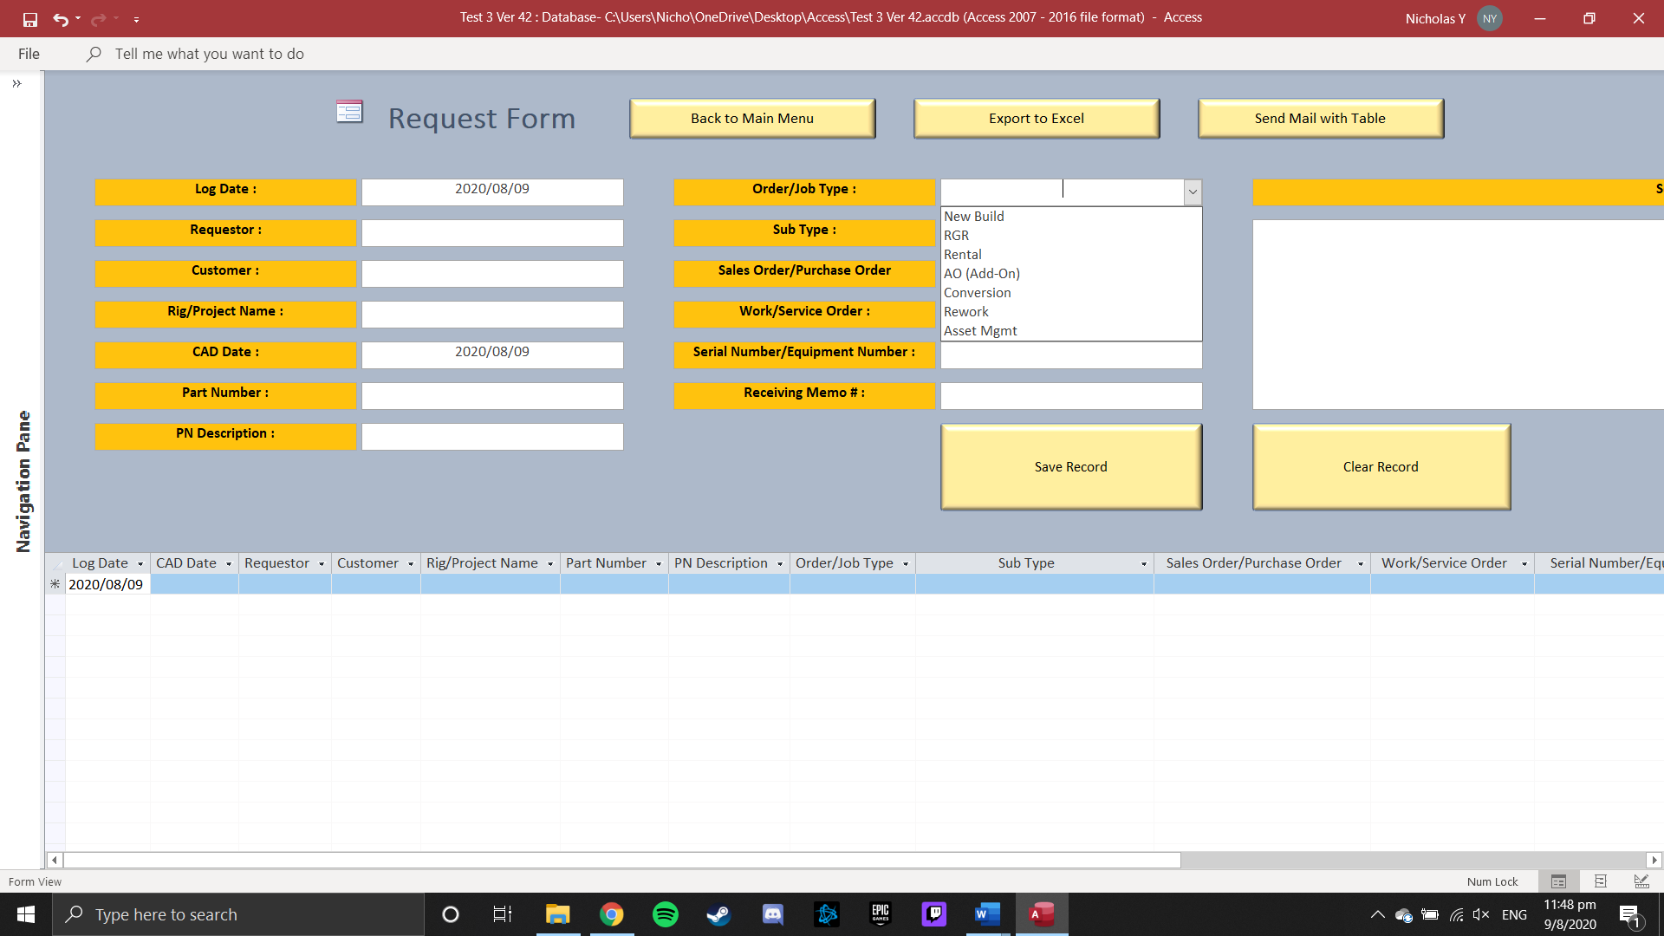

1. Click on beside [Order/Job Type] field for the Drop-Down Selection



1. Click on beside [Sub Type] field for the Drop-Down Selection

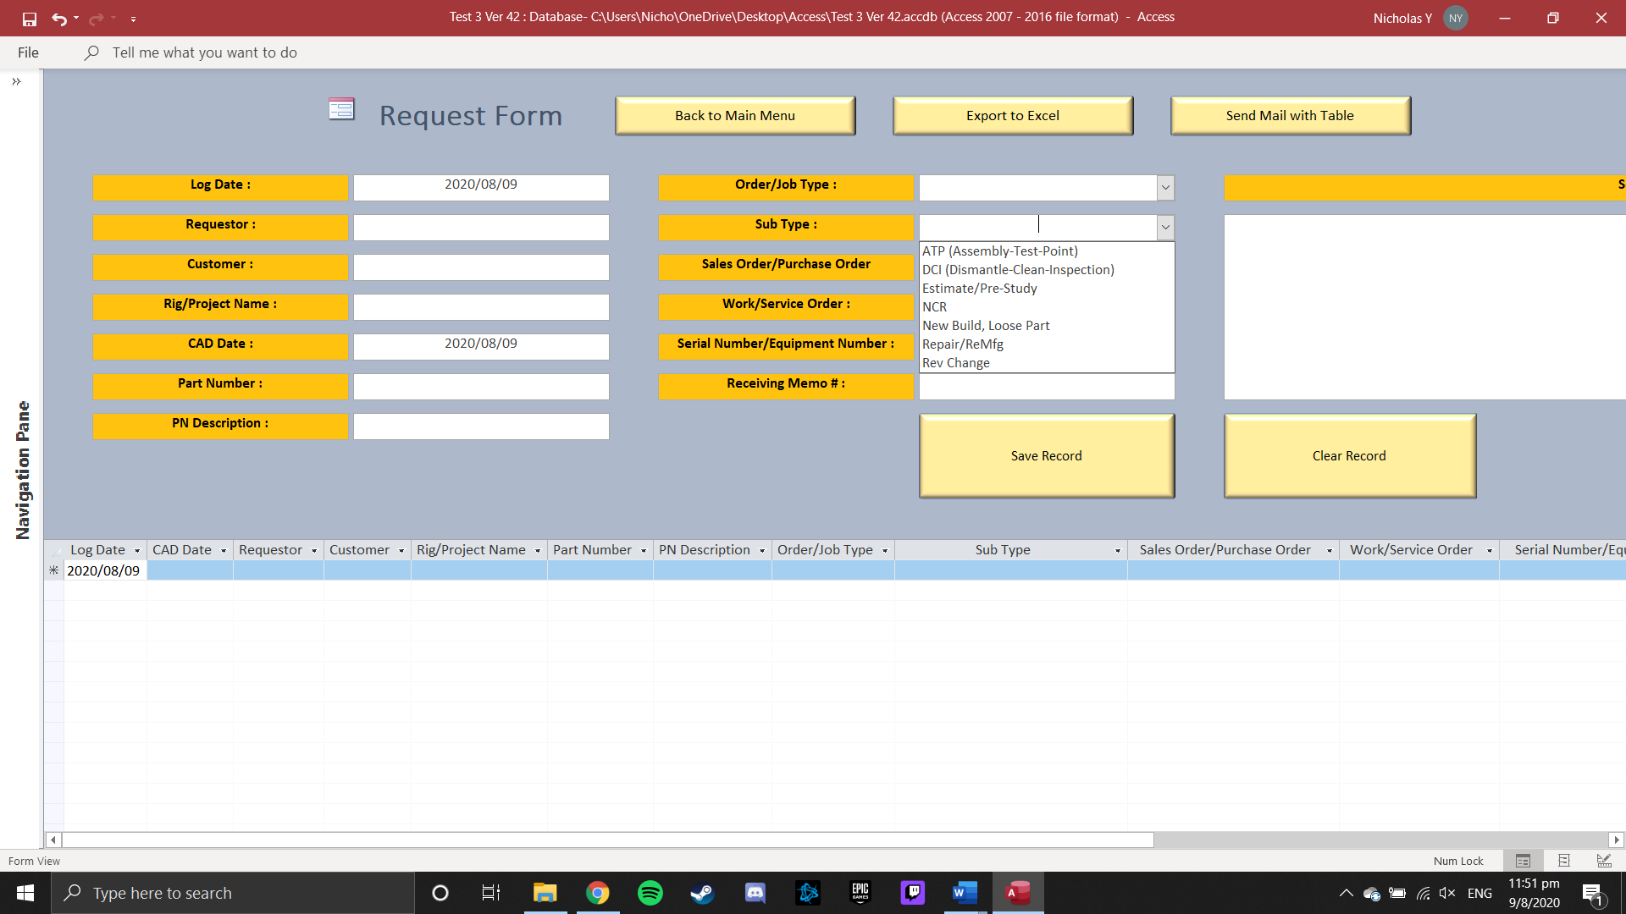

1. 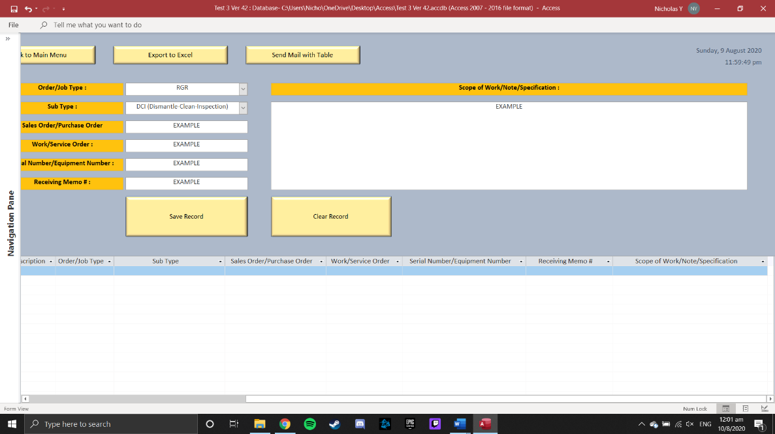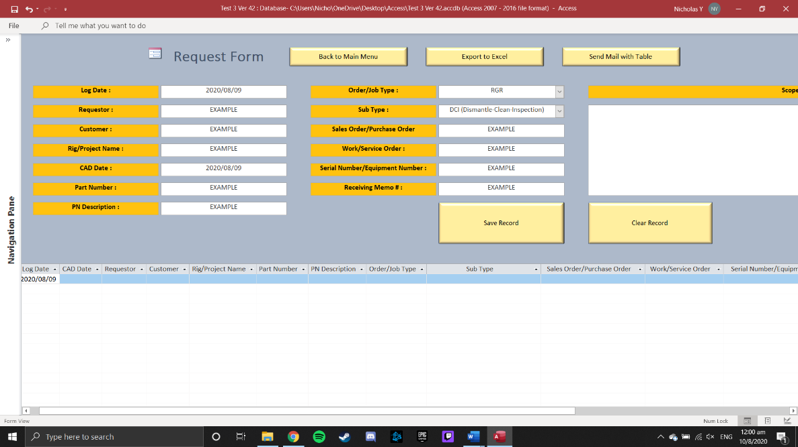Upon completing keying in the fields required,
2. Press ‘Save Record’ Button to save the record into the table below

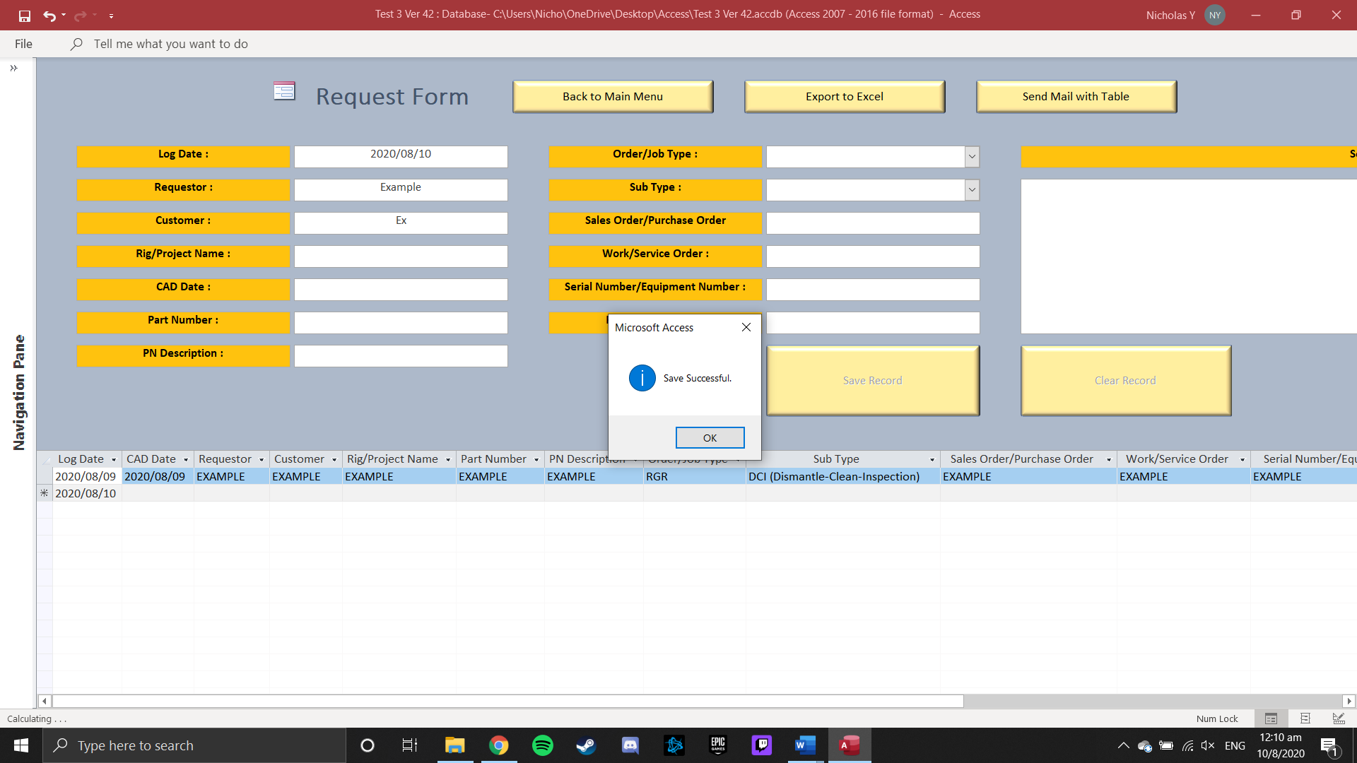

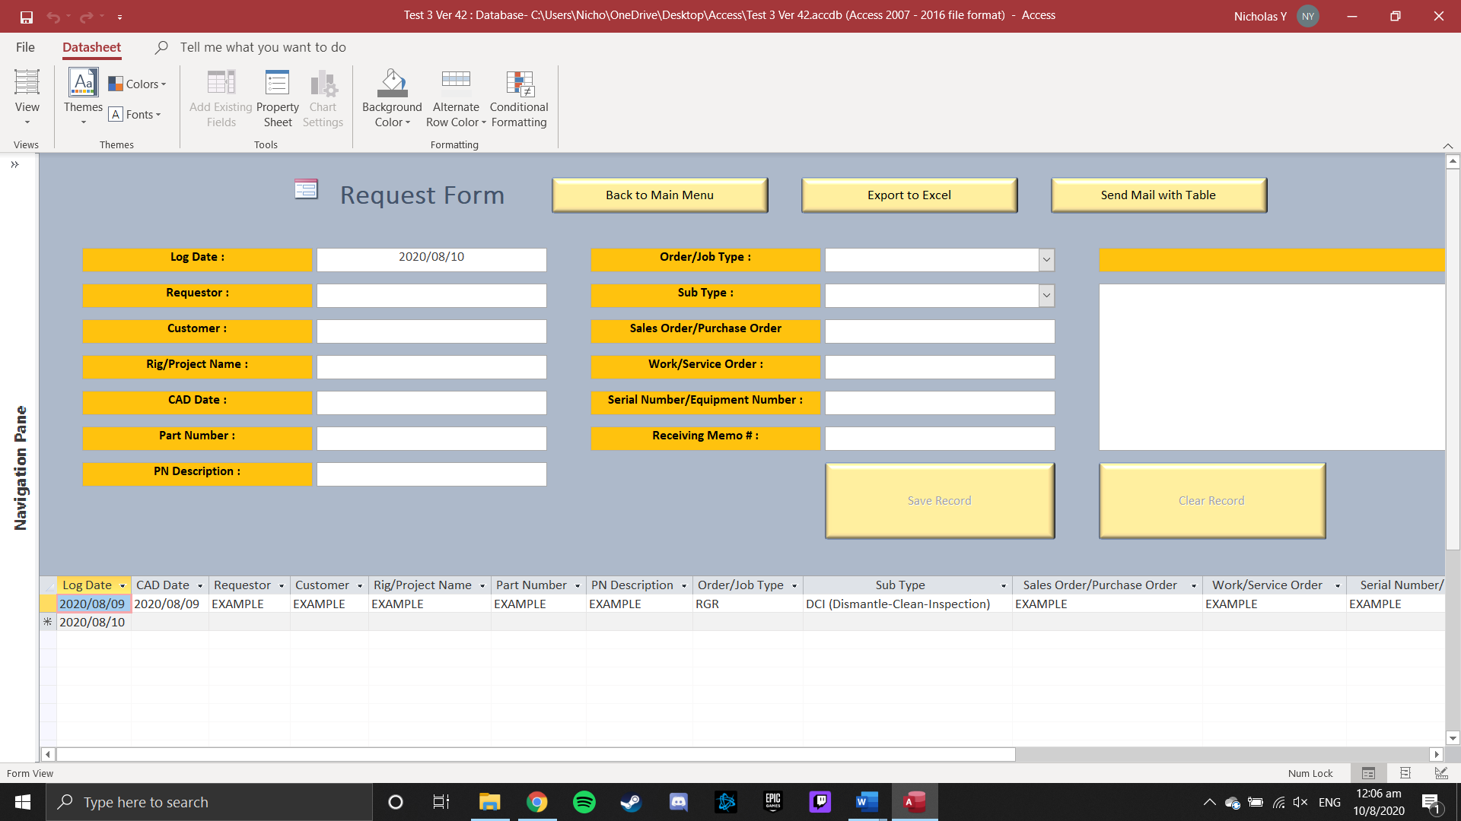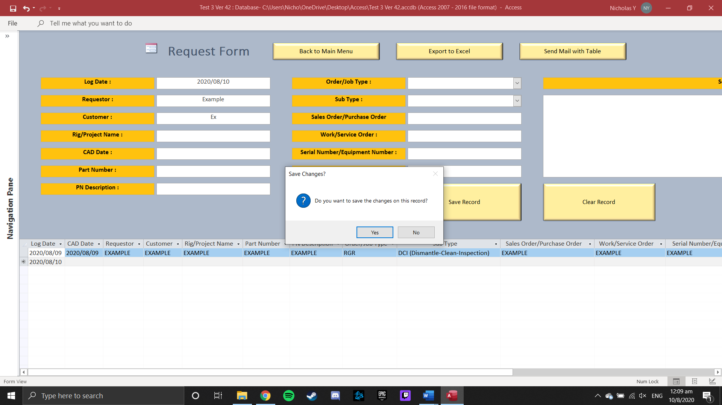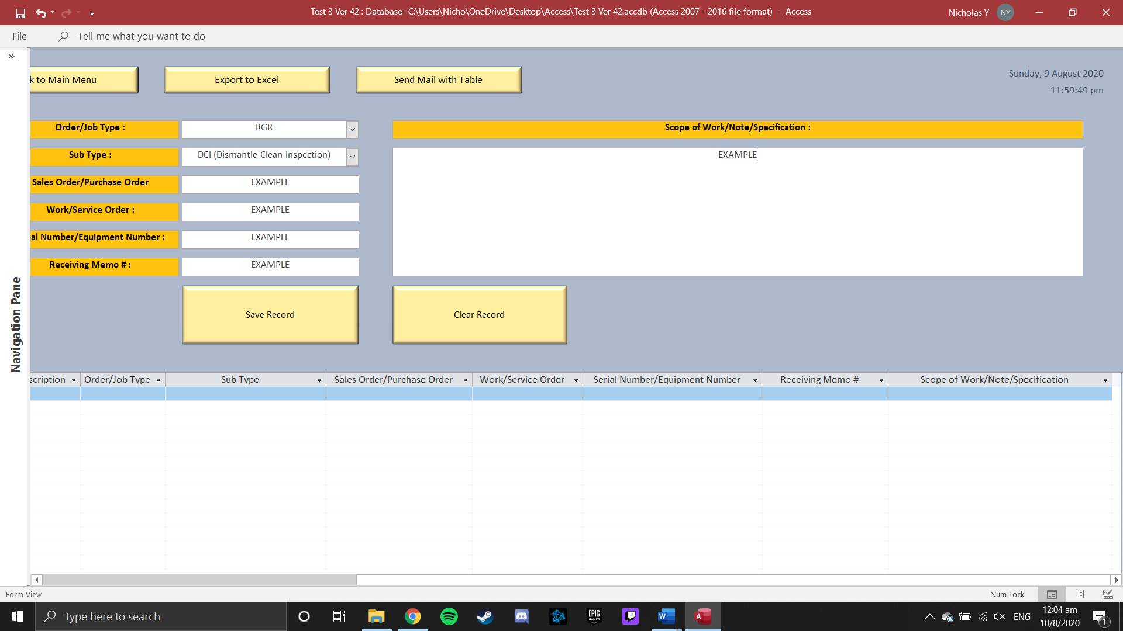

1. Or Press ‘Clear Record’ to clear away the records in the fields

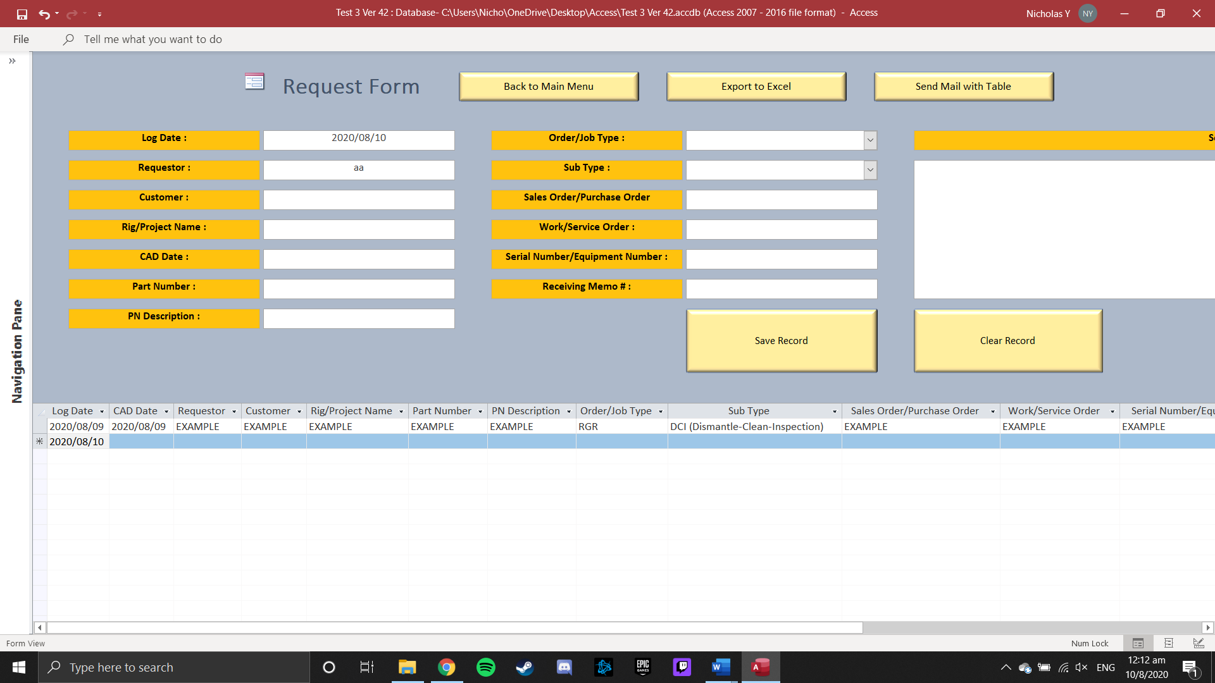

1. Upon Completing keying in the entire table needed

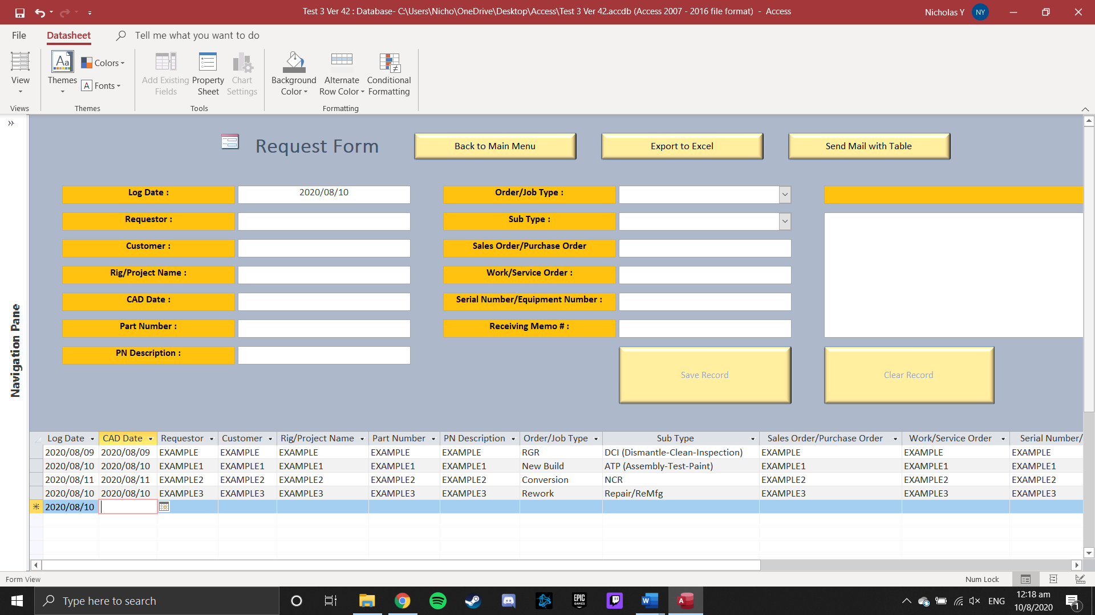

1. Press ‘Export to Excel’ Button to save the file to ‘..\Documents\’ folder

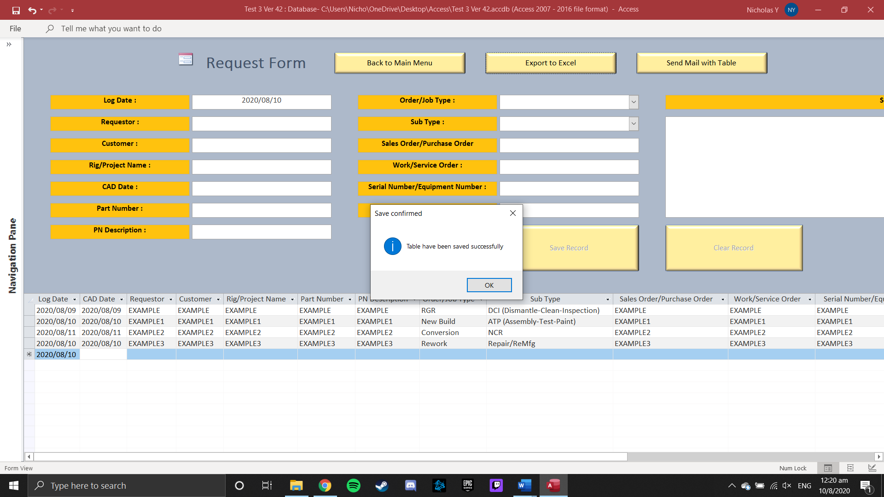

1. File name will be saved under Request (Todays Date) user.xlsx

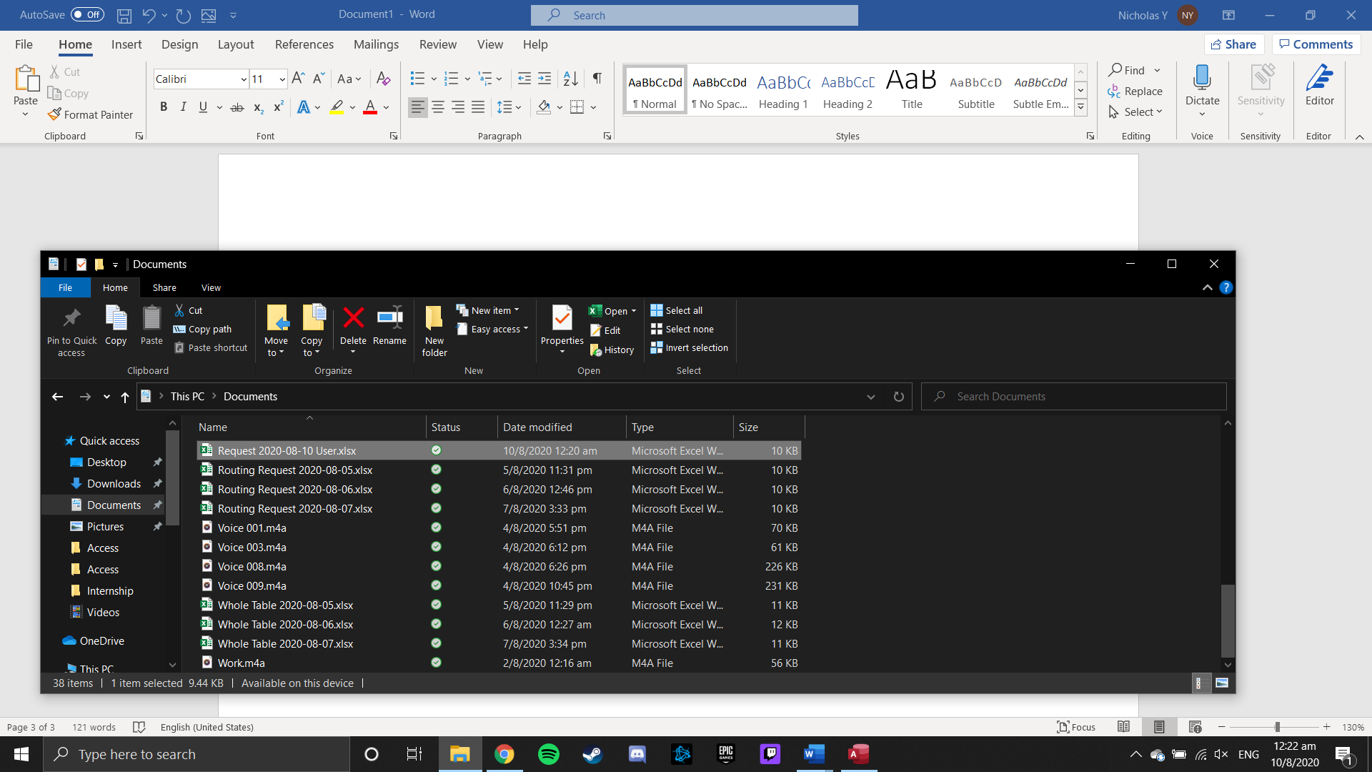

1. Opening the Excel file will be in the same format as the table in MS Access

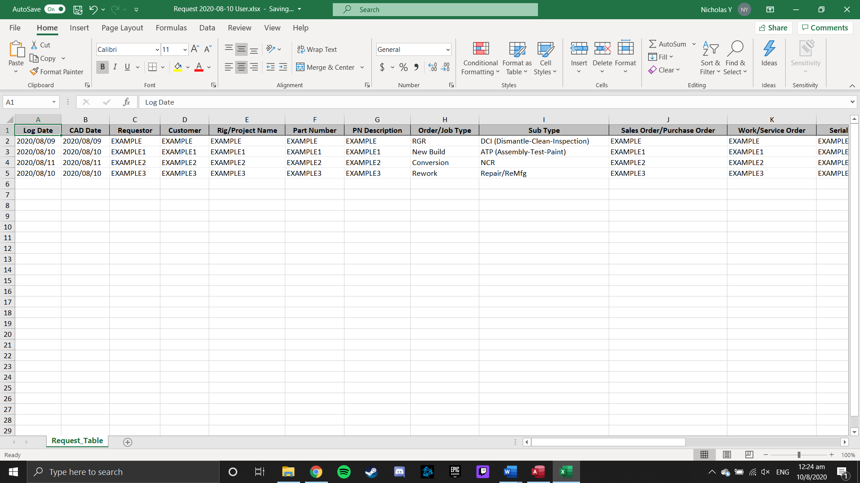

1. Press ‘Send Mail with Table’ Button to send an email (through Outlook) with HTML table formatted in body and Excel file attached

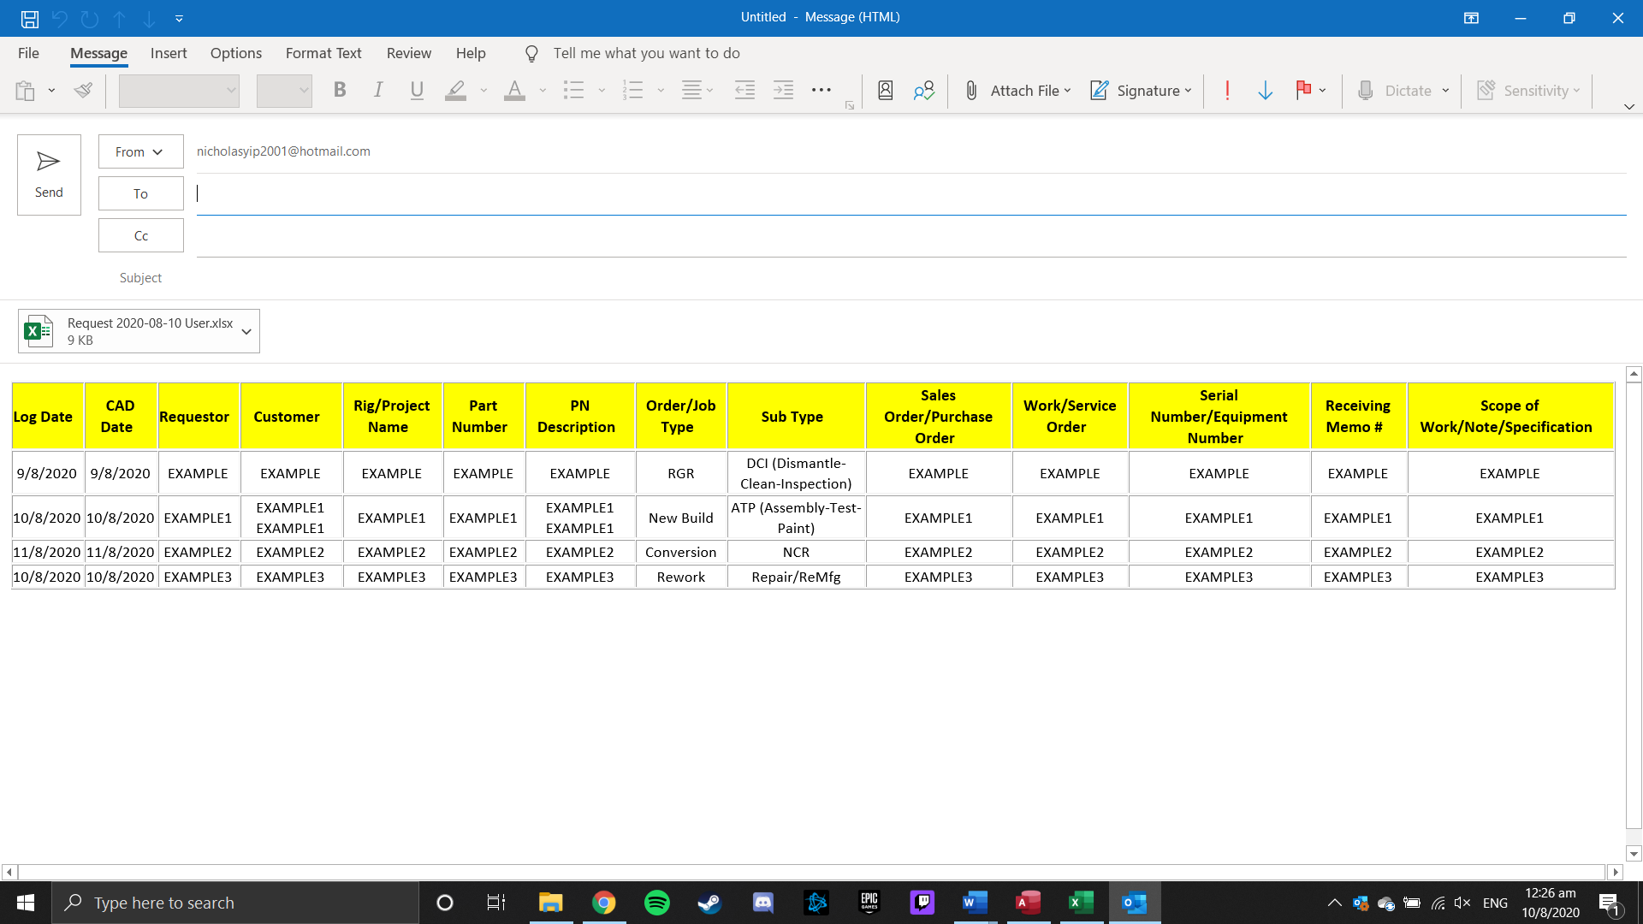

1. Press ‘Back to Main Menu Button’ to return to Main Menu

*Note that closing and opening the form again will clear all the records in table*

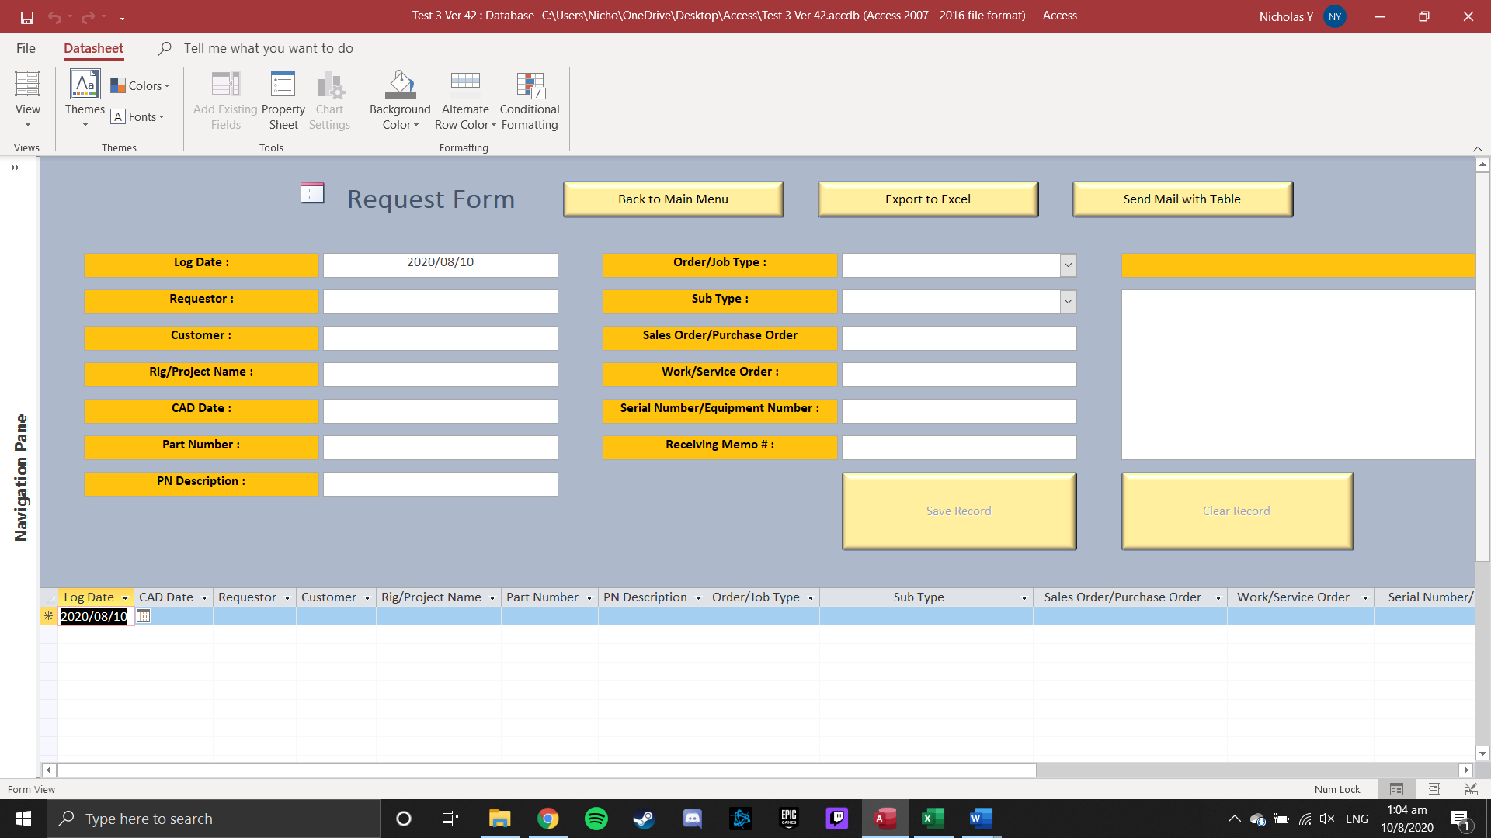

**Industrial Engineering Form**

1. Click Industrial Engineering in Main Menu



1. Enter the Username and Password

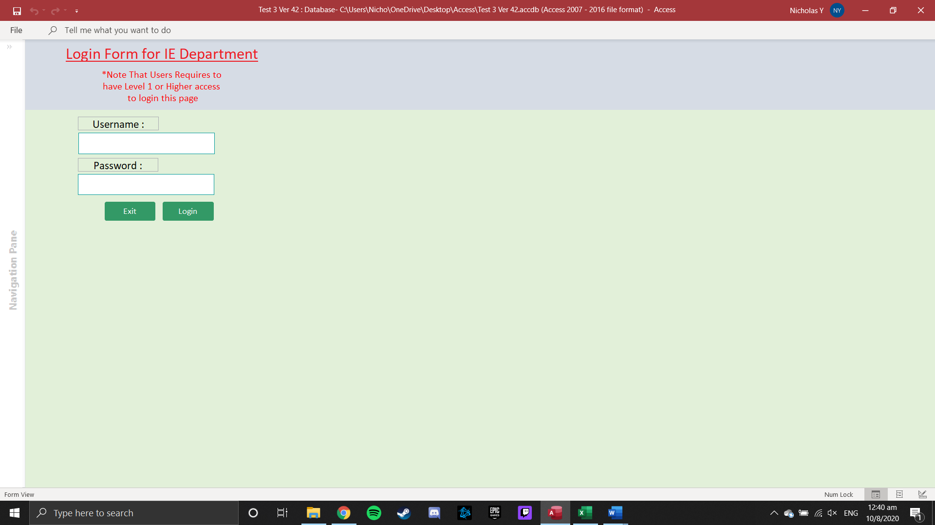

1. Additional fields to be keyed in for Person-In-Charge

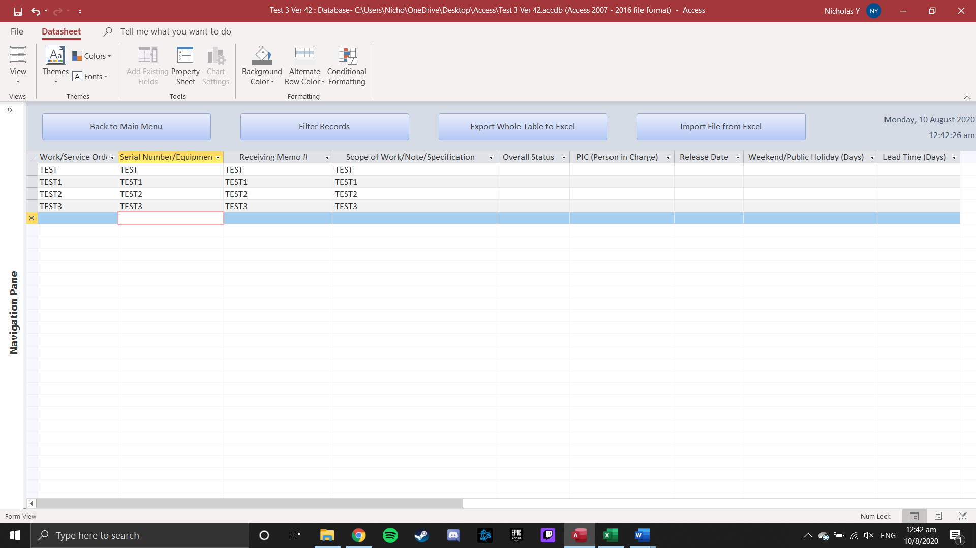

1. Click on beside [Overall Status] field for Drop-Down Selection

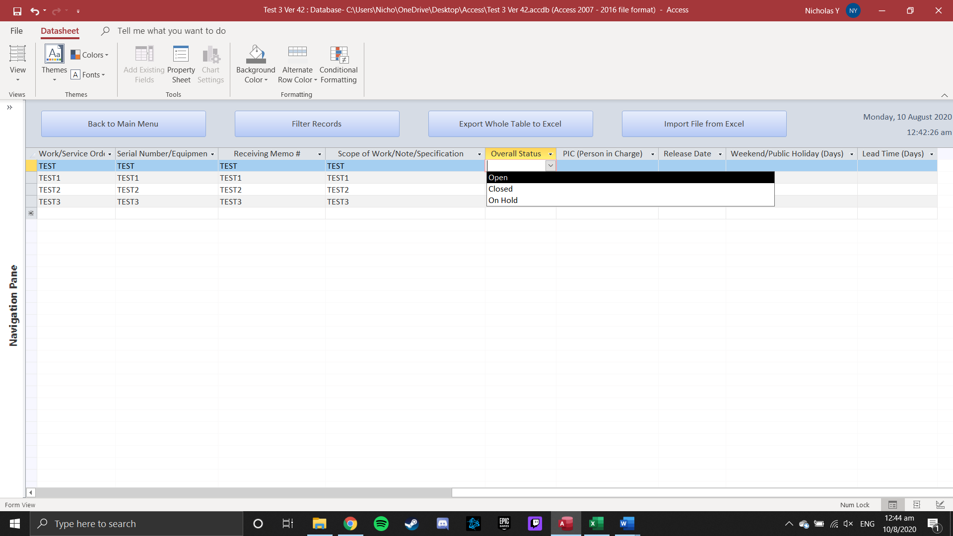

1. Click on beside [PIC (Person In Charge)] field for Drop-Down Selection

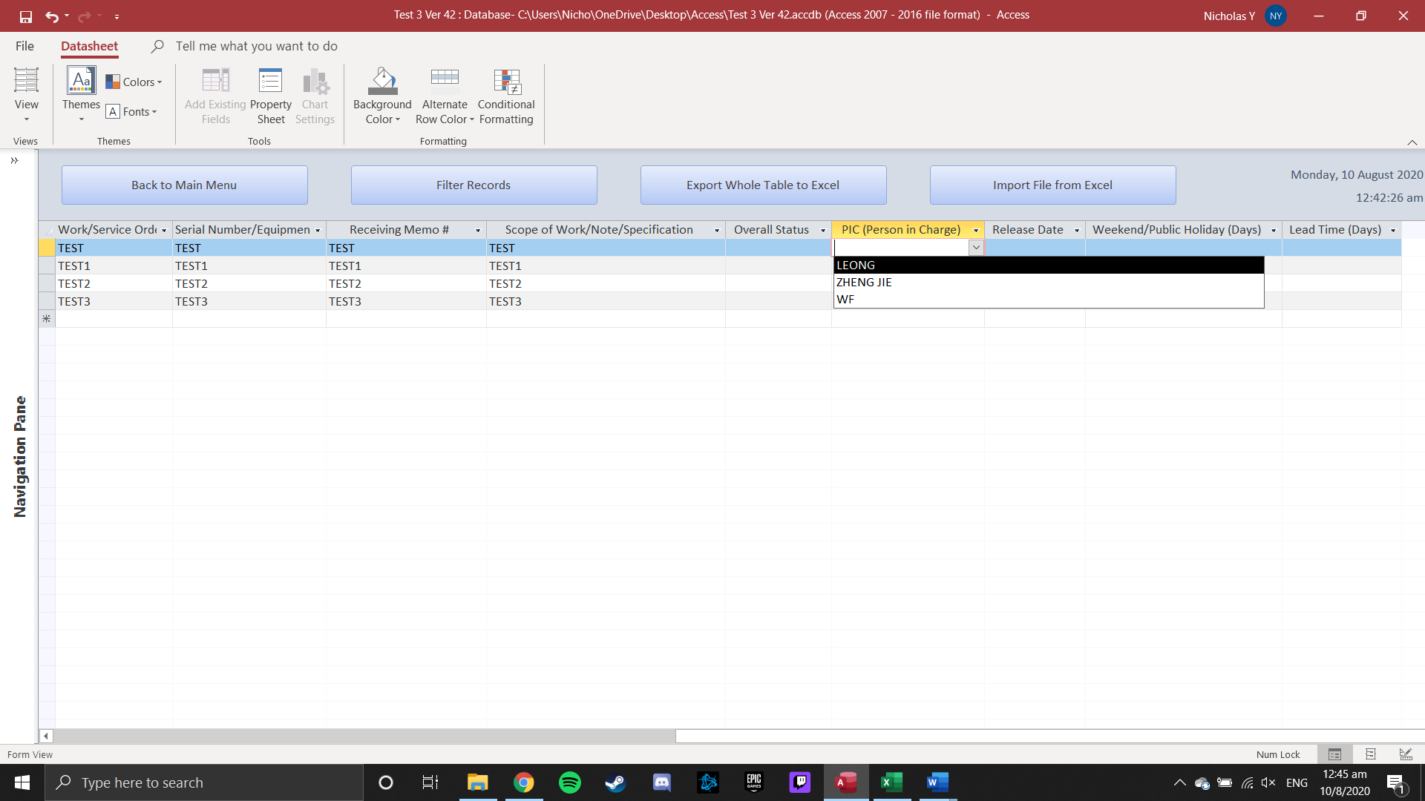

1. Click on beside [Release Date] to select date using Date Picker

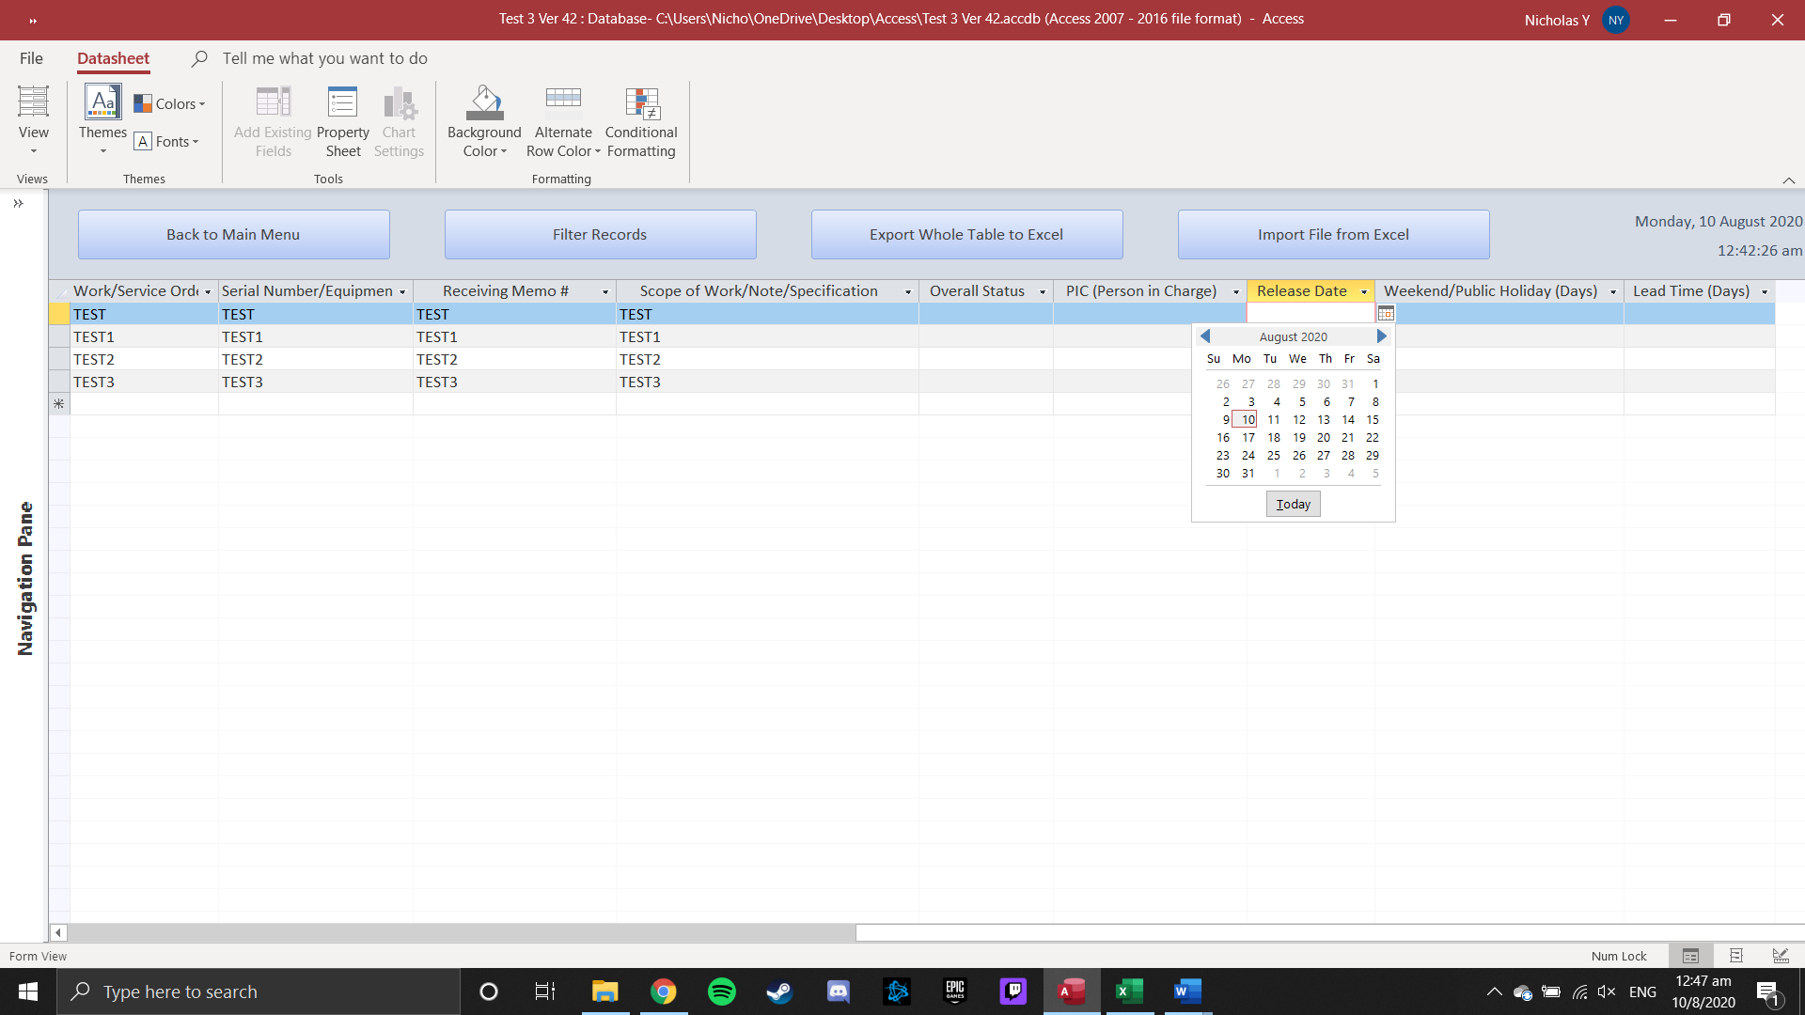

1. Key in the number of days of Weekend/Public Holiday in the [Weekend/Public Holiday (Days)] fields
2. [Lead Time (Days)] field will be calculated automatically using [Release Date] - [Log Date] - [Weekend/Public Holiday (Days)]
3. Press ‘Export Whole Table to Excel’ Button will save the whole table in ‘..\Documents\’ folder

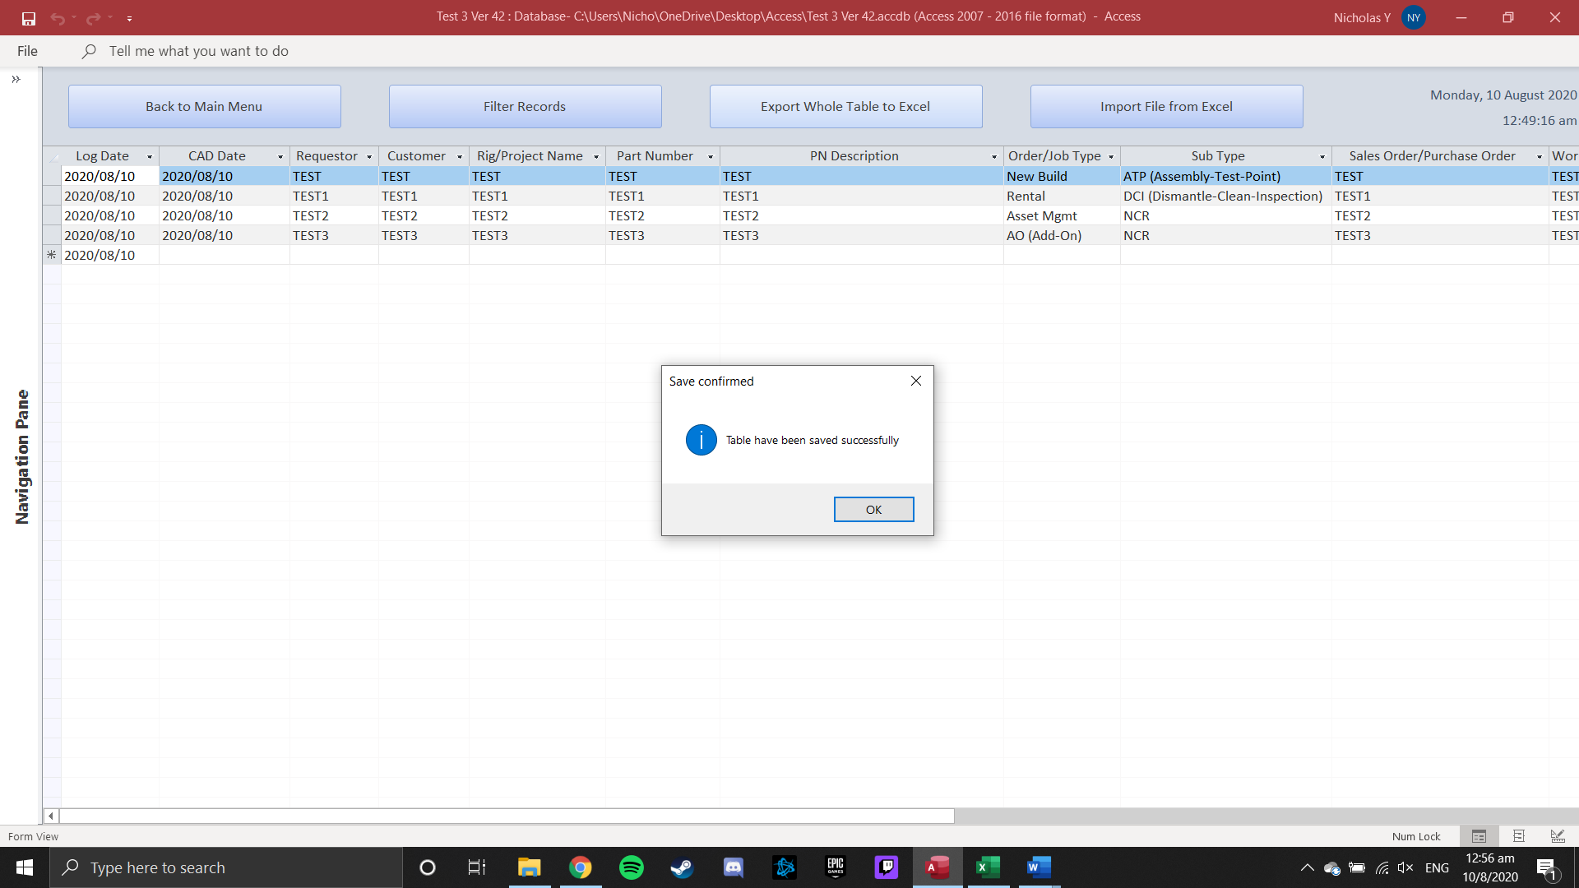

1. File name will be saved under Whole Table (Todays Date) user.xlsx

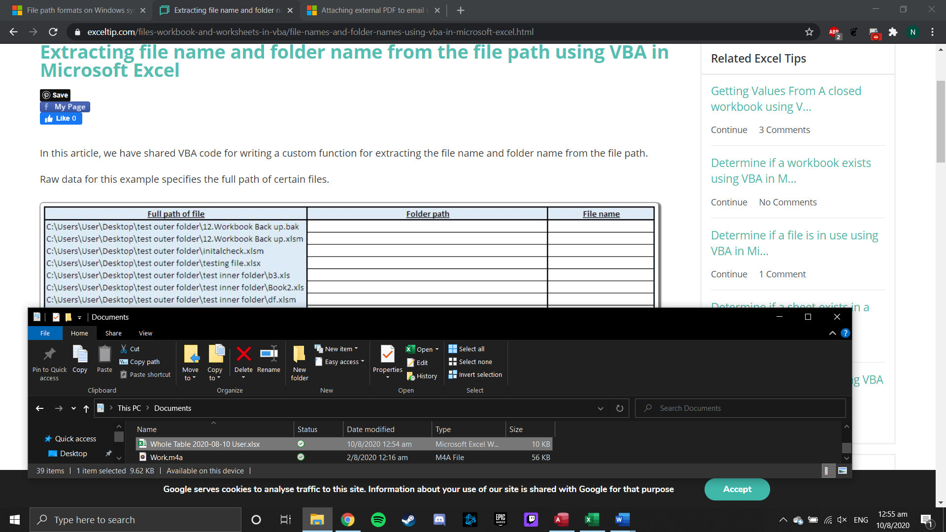

1. Press ‘Filter Record’ Button will open the Filter Form



1. Press ‘Import File from Excel’ Button will open the Import Form



1. Press ‘Back to Main Menu Button’ to return to Main Menu

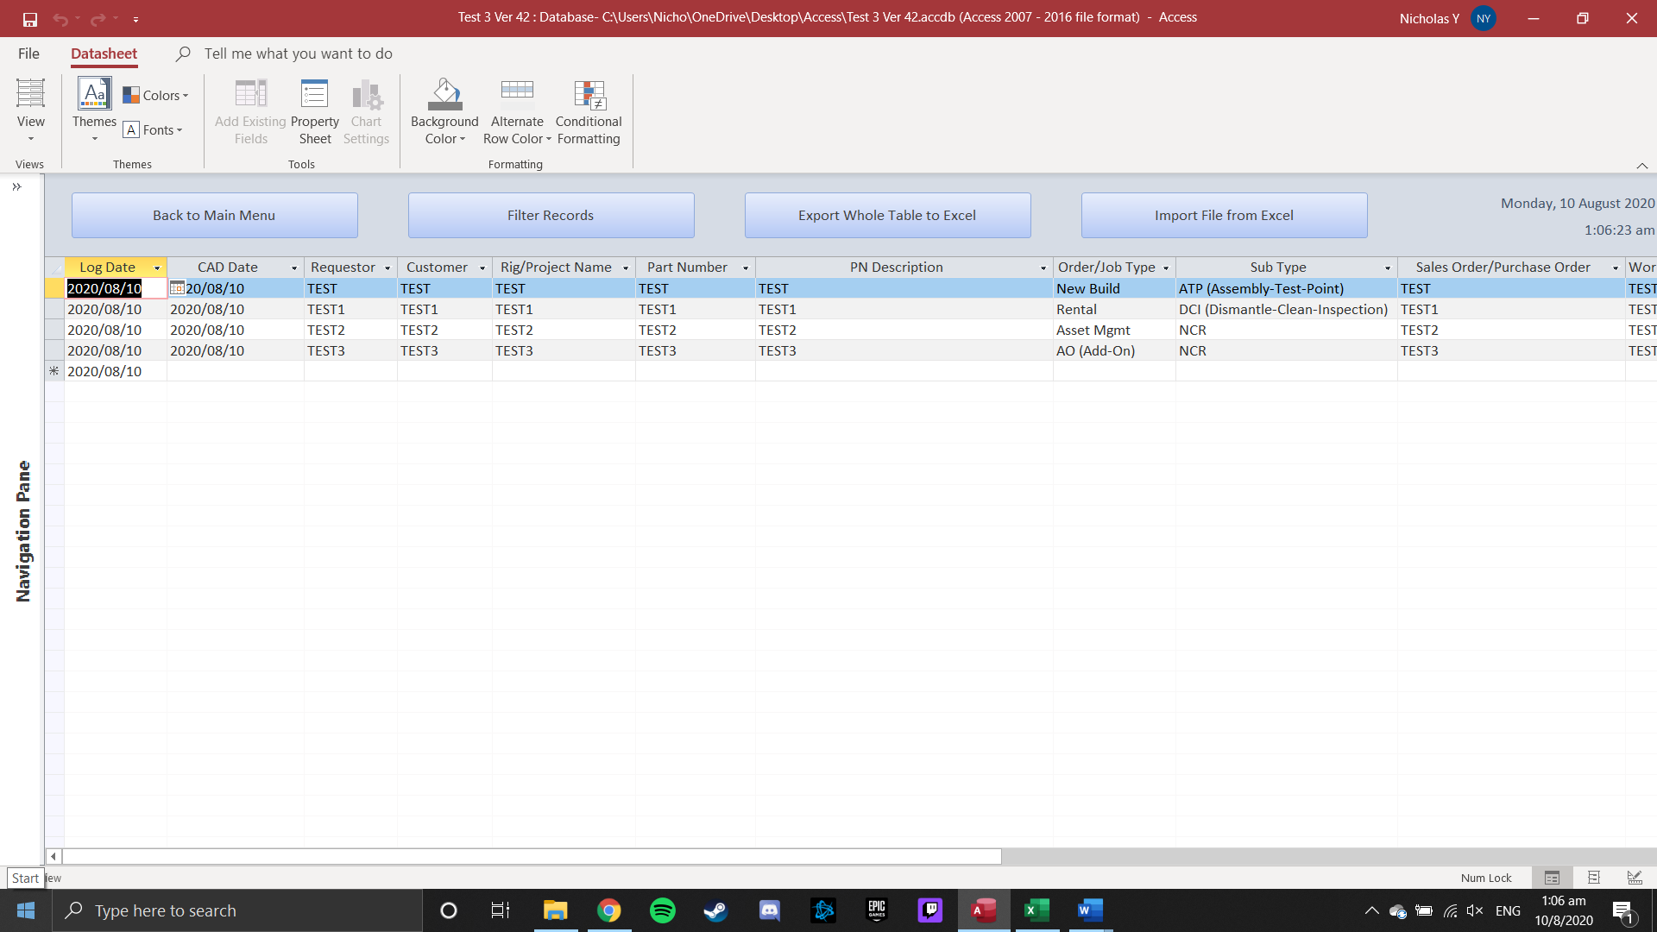

**Filter Form**

1. Click the ‘Filter Records’ Button from Industrial Engineering Form



1. Click on beside the ‘Requestor’ combo box to filter the table based on ‘Requestor’

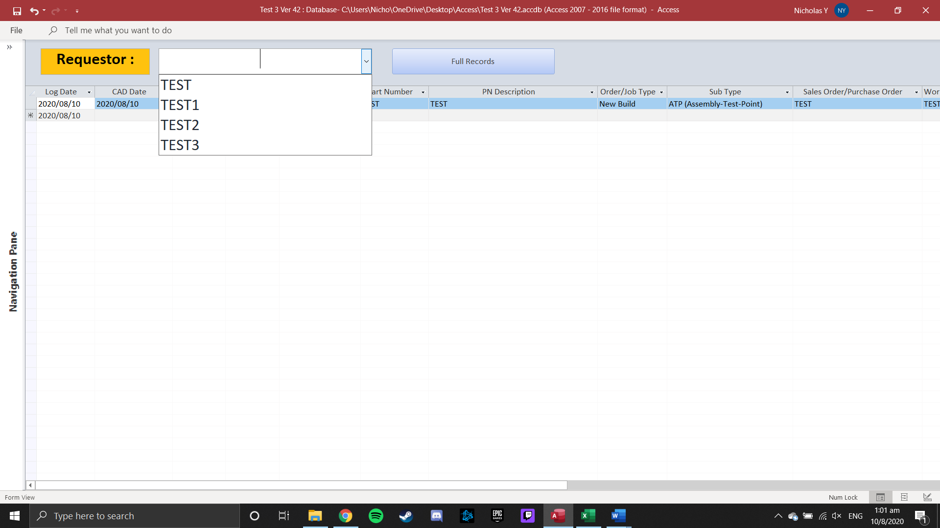

1. Press ‘Full Records’ Button to return to Industrial Engineering Form



**Import Form**

1. Click the ‘Import File from Excel’ Button from Industrial Engineering Form



1. Press ‘Browse’ Button to search the file Requestor sent

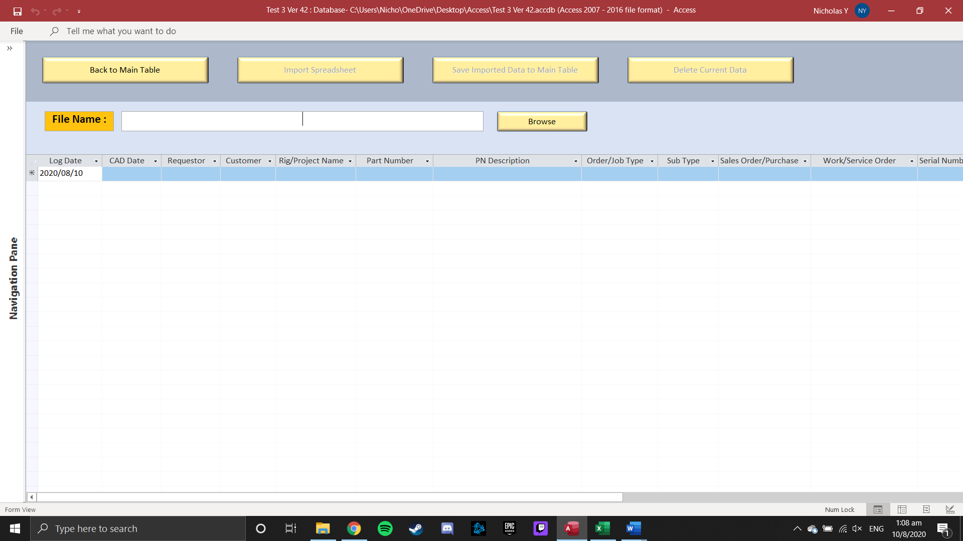

1. Upon selecting the file, the file path will be show in the [File Name] field

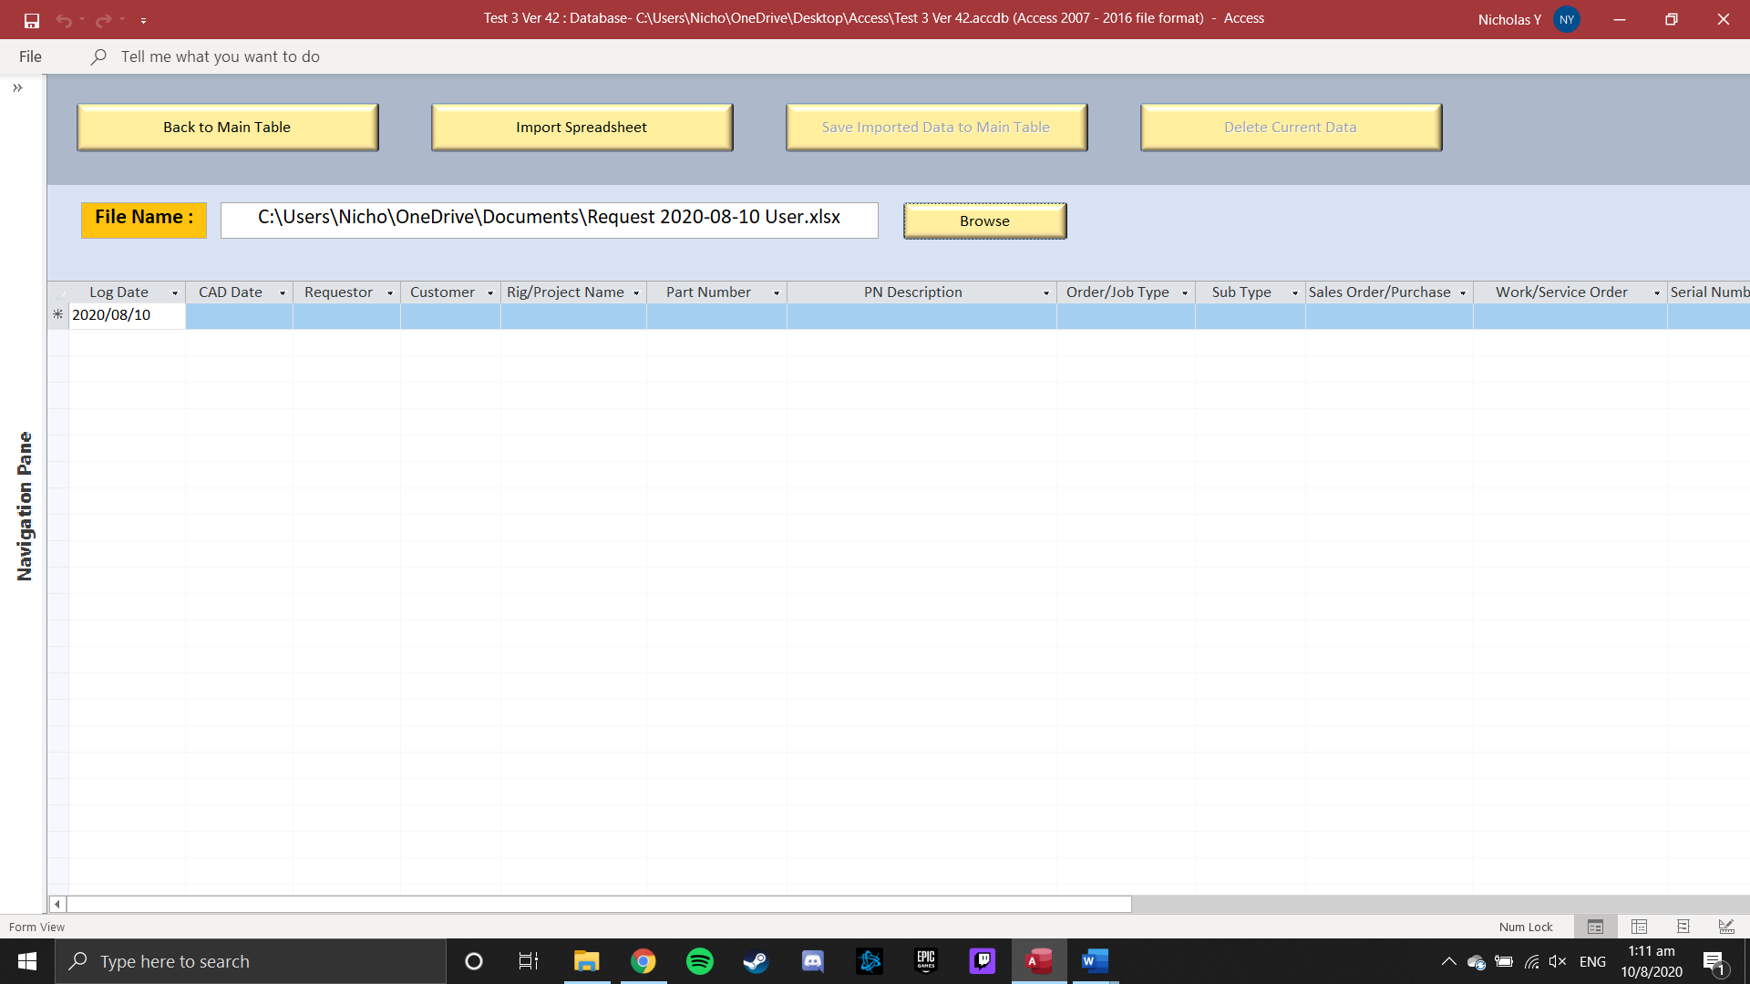

1. After ensuring it is the correct file, press ‘Import Spreadsheet’ button



1. The records will be shown in the table below

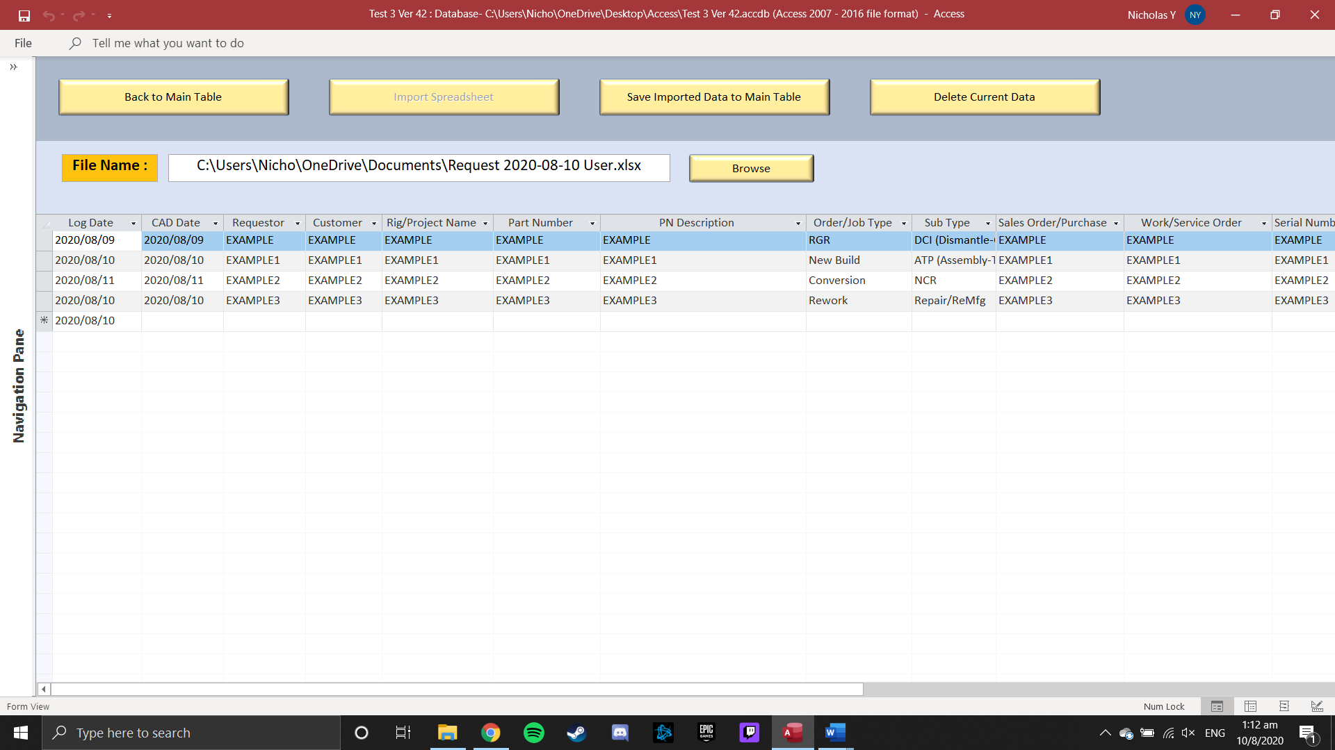

1. Changes can be made to the table directly

*Note that the currently imported data is not yet saved to main table*

1. To save the imported data to main table, press ‘Save Imported Data to Main Table’ button

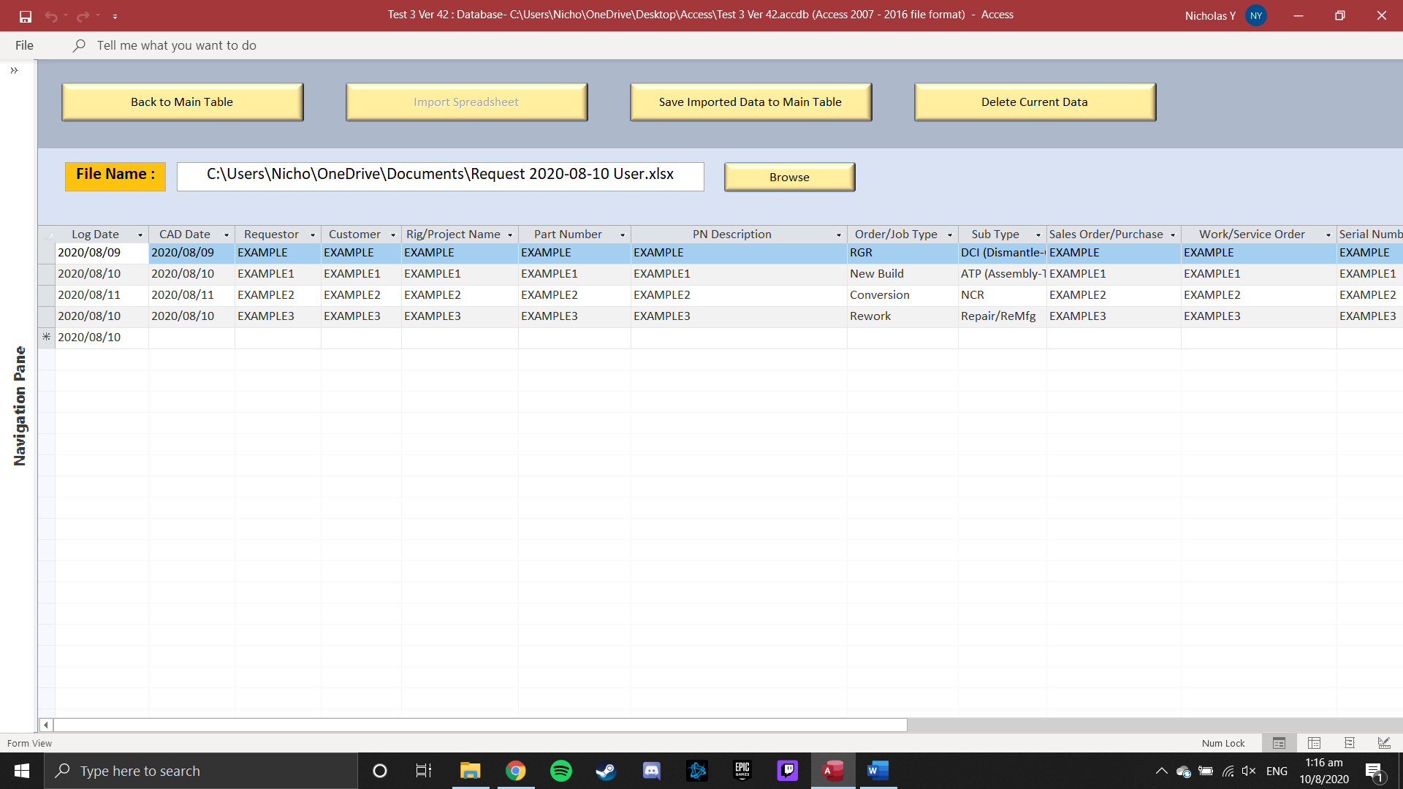

1. Records in the table will be cleared, once ‘Save Imported Data to Main Table’ button is pressed
2. If realized that the imported file is incorrect, table can be cleared by pressing ‘Delete Current Data’ button



1. Press ‘Back to Main Table’ Button to return to Industrial Engineering Form

*Note that closing and opening the form again will clear all the records in table*



**User Admin Form**

1. Click User Admin in Main Menu



1. Enter Username and Password

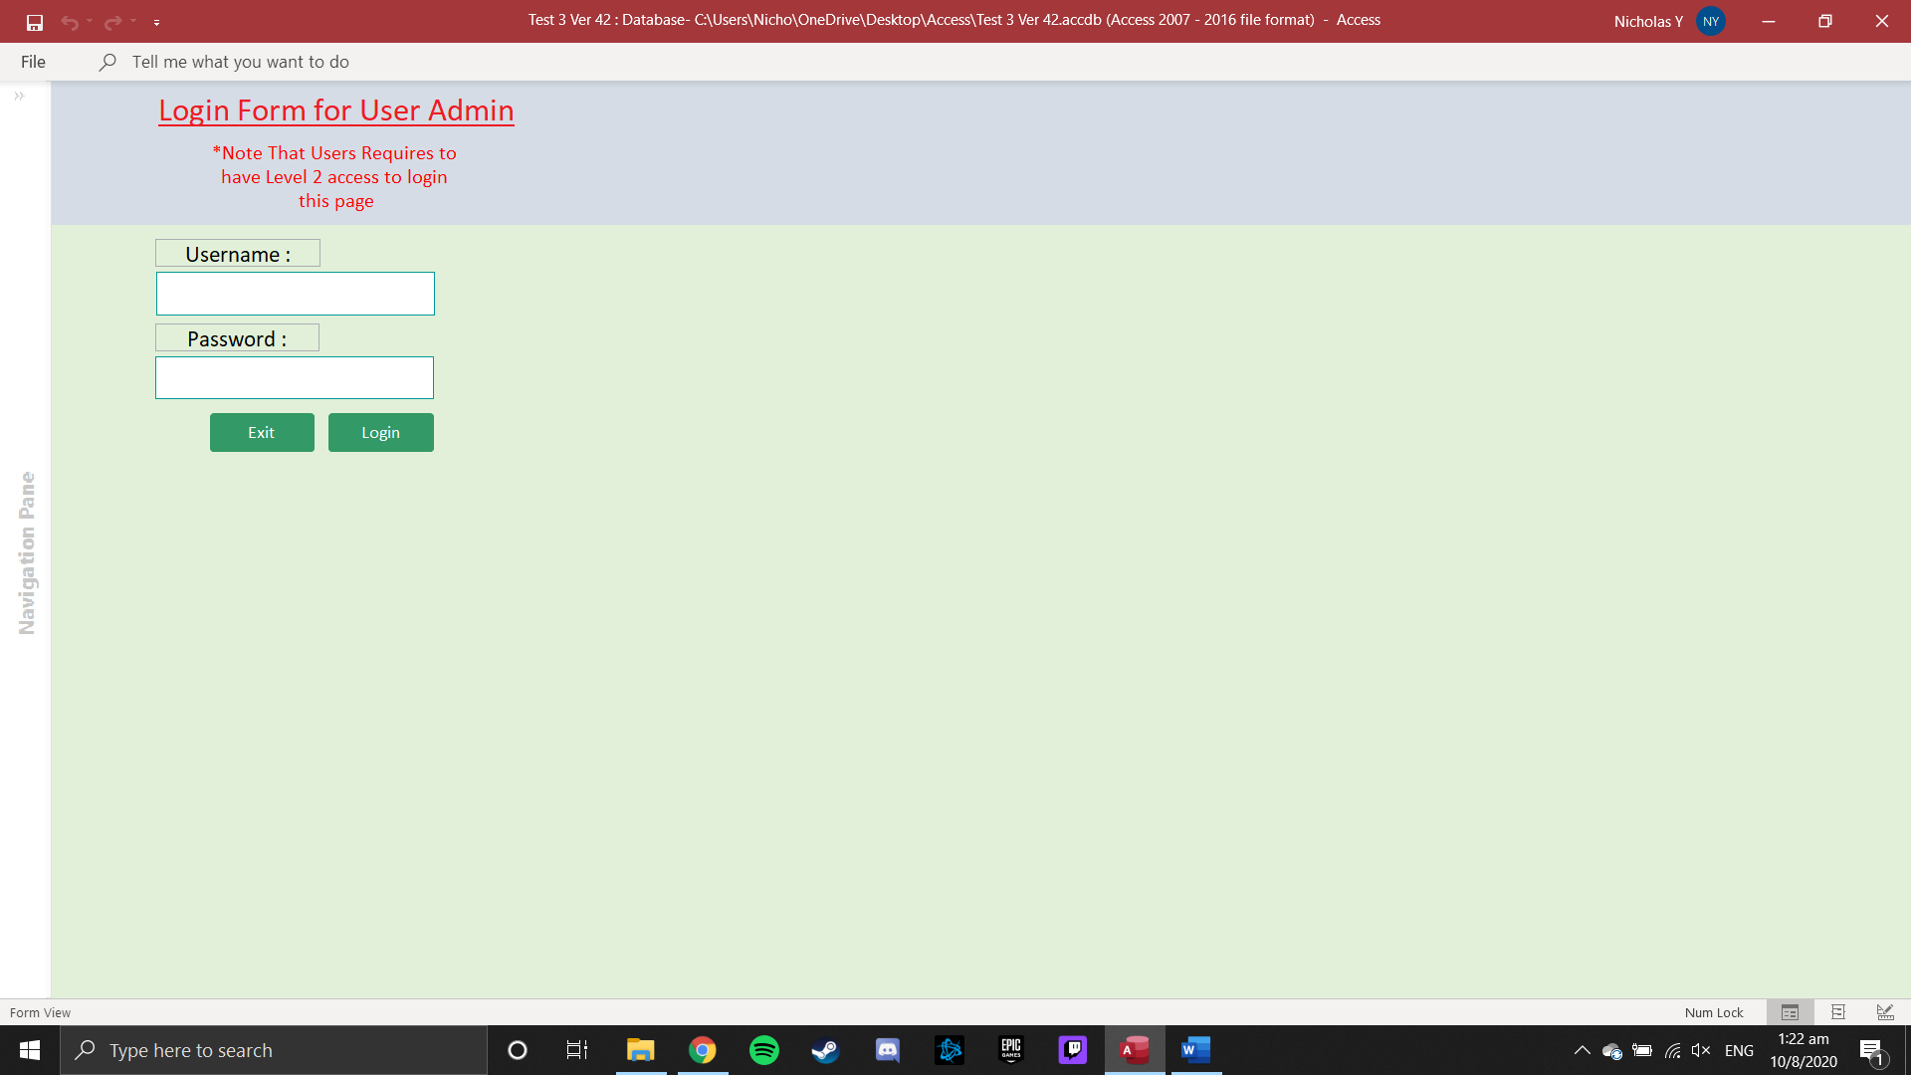

1. To add new user, key in the field of Username and Password

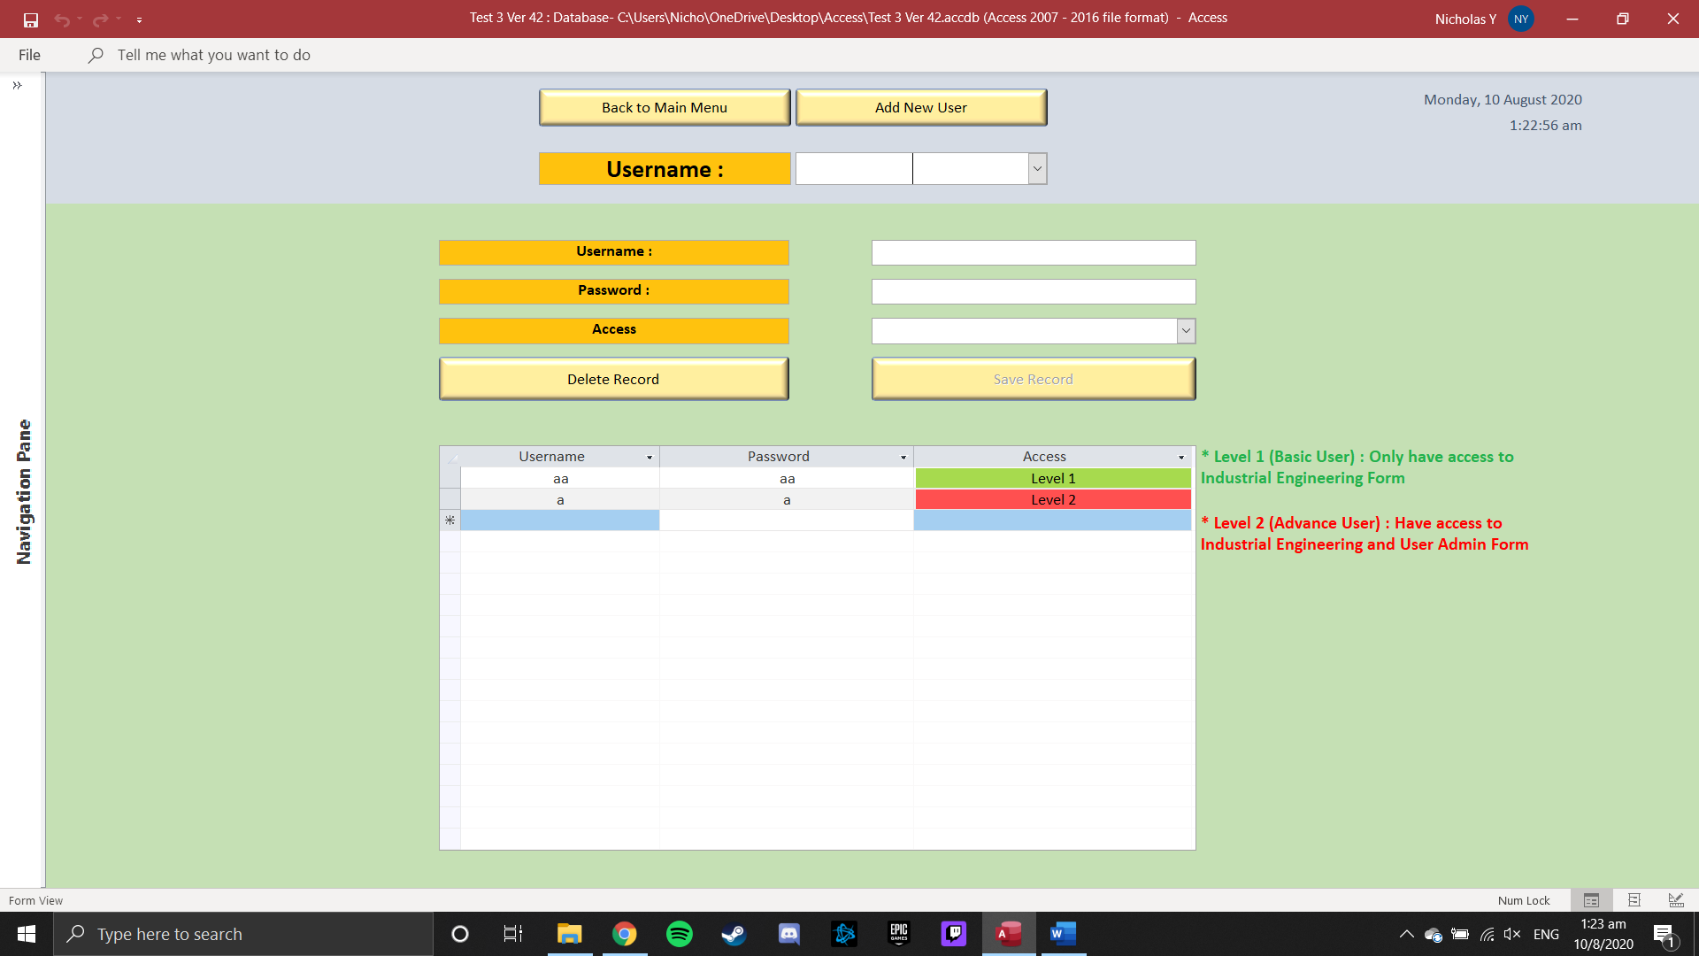

1. Click on beside [Access] field to select from the Drop-Down selection to select an

access level for the User

* Level 1 (Basic User): Only have access to Industrial Engineering Form

* Level 2 (Advance User): Have access to Industrial Engineering and User Admin Form

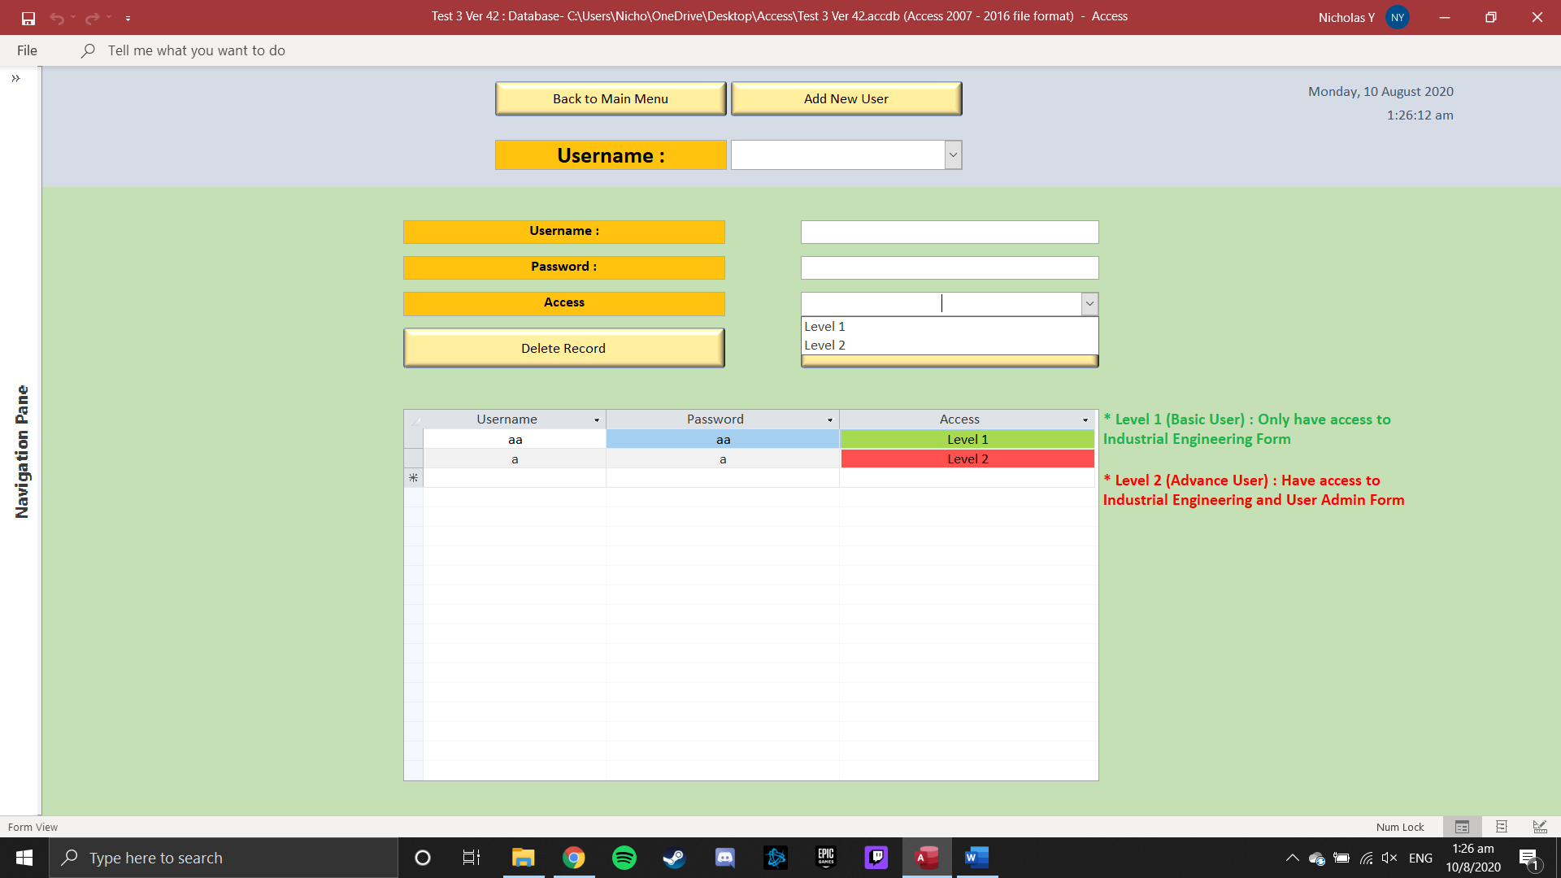

1. Upon Completing, press ‘Save Record’ Button to save the Username, Password and Access level
2. Press ‘Add New Record’ to clear the fields, to allow to add another user

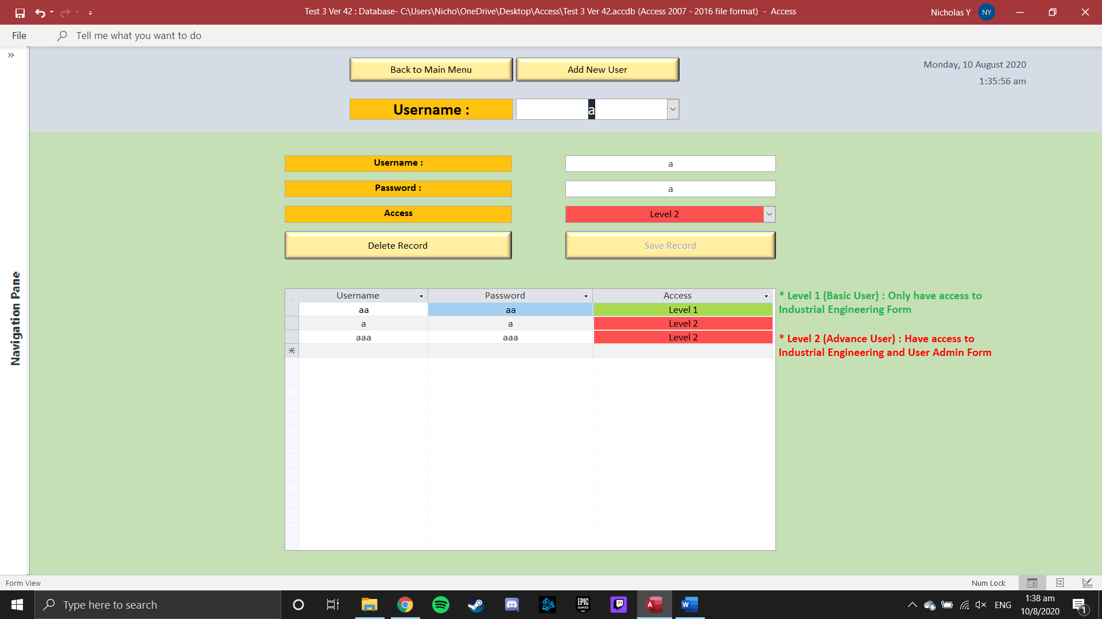

1. Records of the Users will show up in the table below, which can also be edited

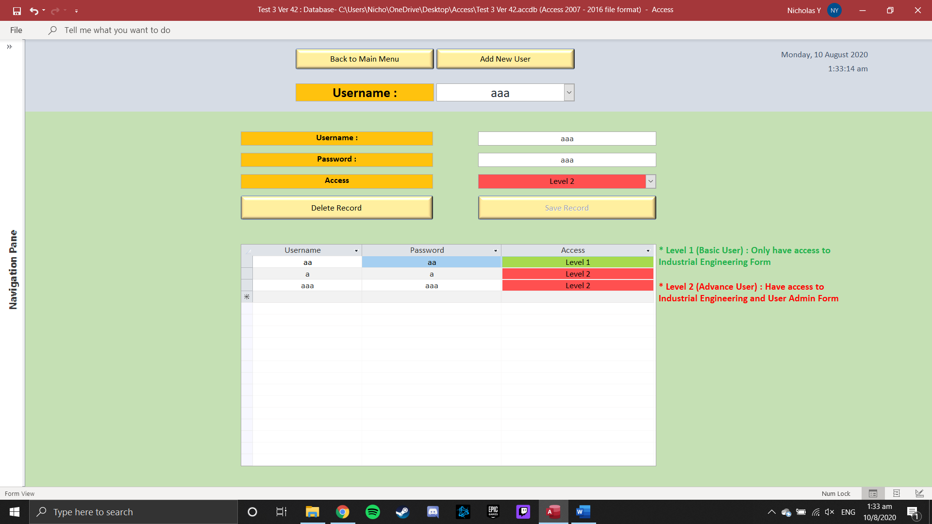



1. Click on beside the [Username] combo box to select individual Users

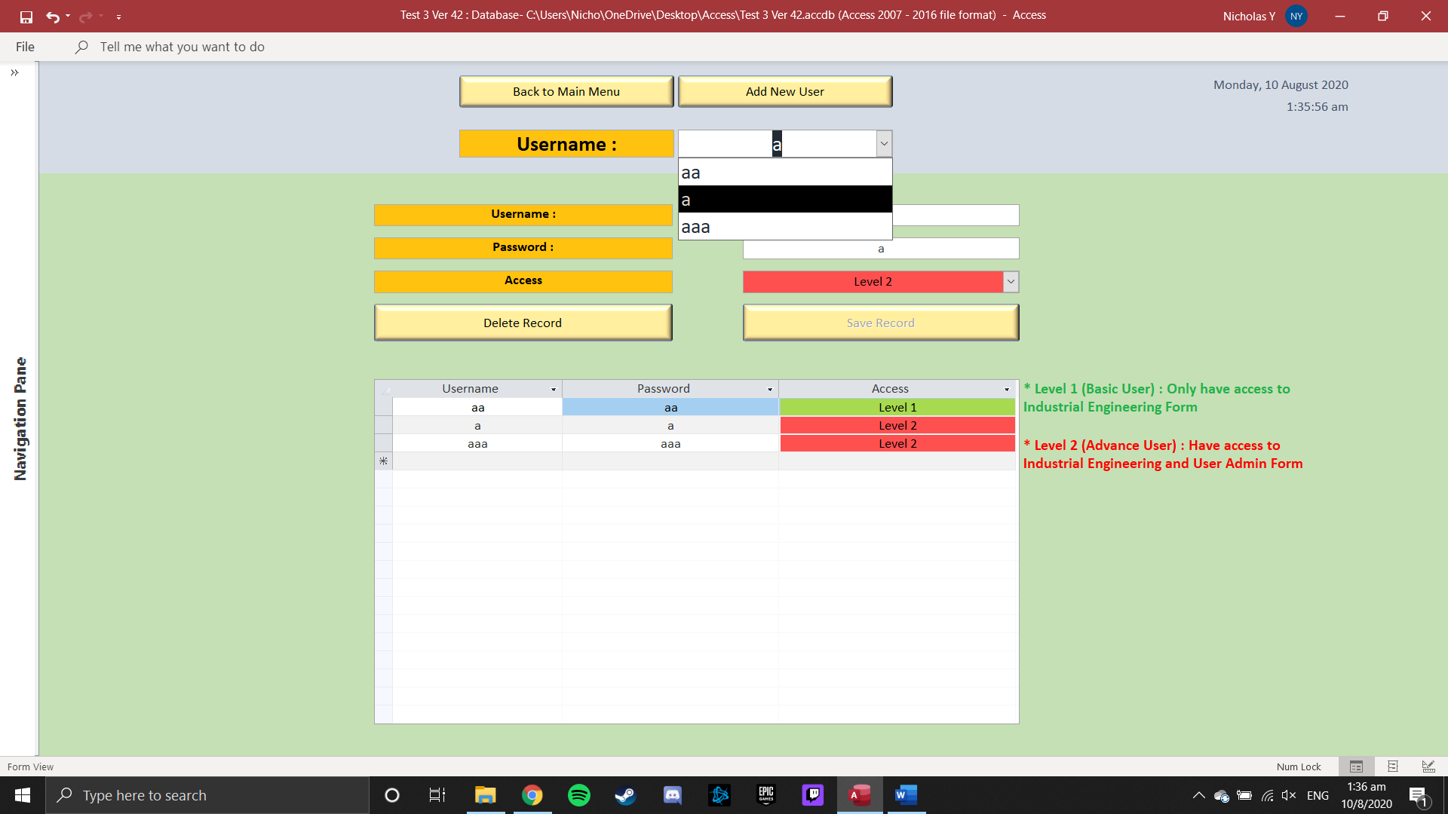

1. Which can be editing in the fields below

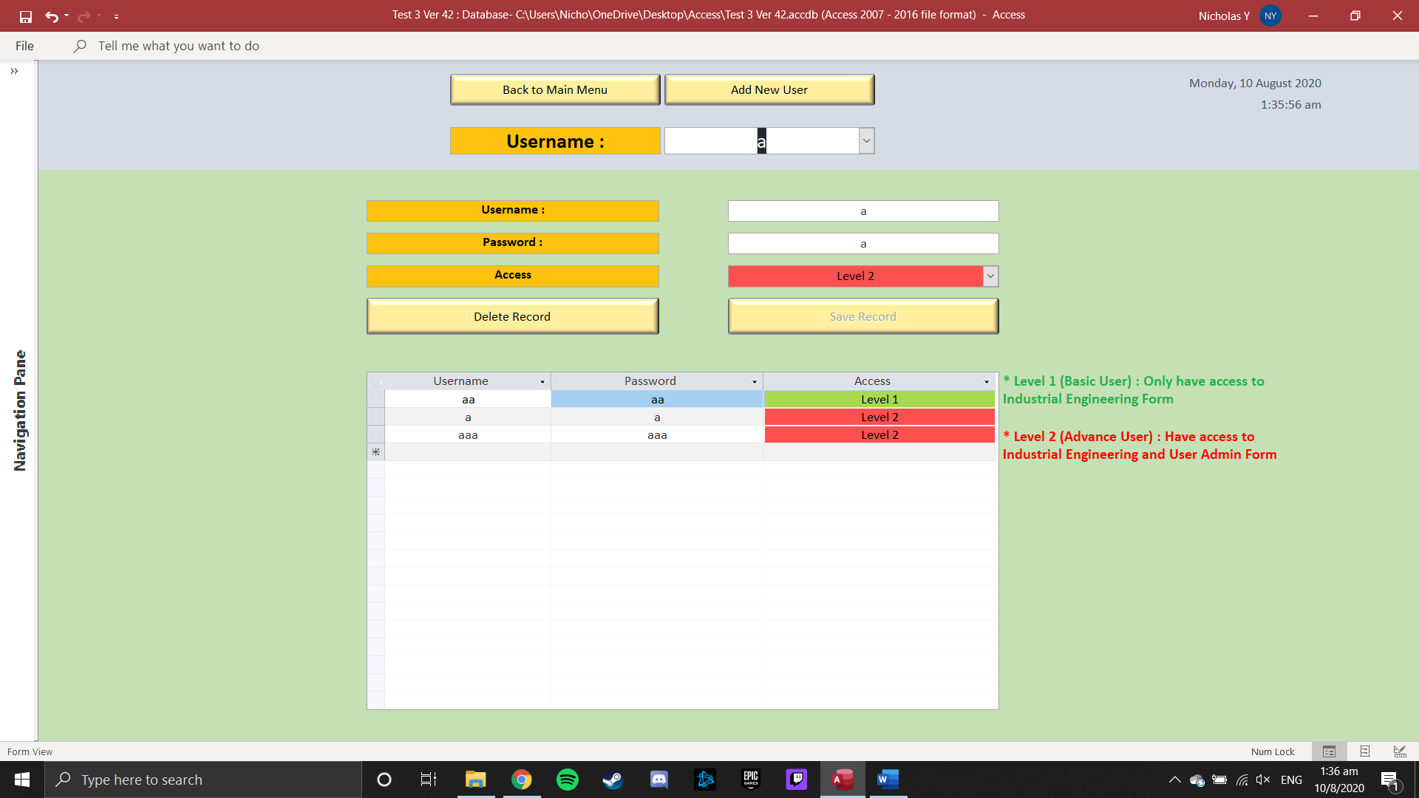

1. Pressing the ‘Delete Record’ Button will delete the currently selected Username and Password of that user



1. Press ‘Back to Main Menu’ button to return to main menu

